VILLANOVA UNIVERSITY

DEPARTMENT OF MECHANICAL ENGINEERING

ME 5006-001: CAPSTONE DESIGN

FINAL REPORT

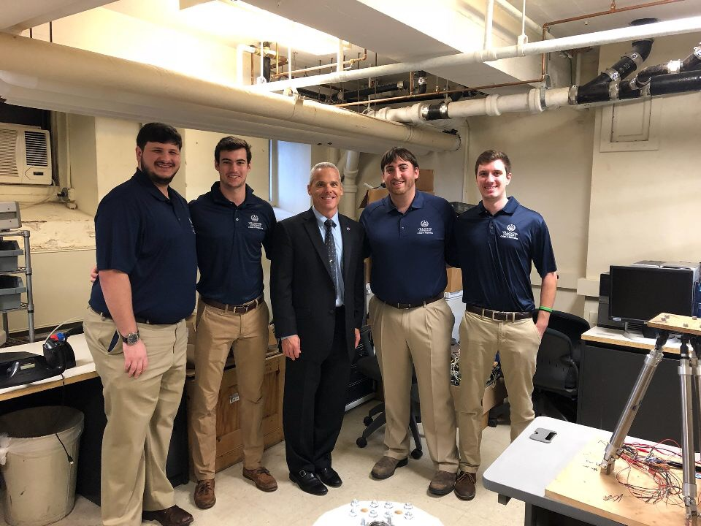

*Team Picture with NASA Flight Director Brian Smith*

BOEING FLIGHT SIMULATOR MOTION BASE

Michael Ubertaccio - Team Leader

Andrew Butler

Brian Dobkowski

George Russell

Tyler Moldovan

BOEING FLIGHT SIMULATOR MOTION BASE

by

Michael Ubertaccio __________________

Andrew Butler ______________________

Brian Dobkowski ___________________

George Russell _____________________

Tyler Moldovan _____________________

……………………………………

FINAL REPORT

Submitted to:

Department of Mechanical Engineering

Villanova University

Villanova, PA 19085

In partial fulfillment of the requirements for Capstone Design in Mechanical Engineering

May 3rd, 2018

Received by _________________________

Date_____________

ABSTRACT

Over the course of the last century, the advancements that have been made in the fields of aerospace and defense have been monumental. From the first flight by the Wright brothers in 1903, to the development of the first reusable rocket booster by SpaceX in 2017, the world as we know it has been altered dramatically. Men have walked the moon, broken the sound barrier, dropped bombs, flown drones, sent probes into deep space, and developed a system of commercial aviation that is now the most efficient form of transportation in the world. An essential contributor to these advancements was the growth of flight simulation technology. Flight simulators and flight simulator motion bases have helped to develop better pilots, educate scientist about aerodynamic principles, and prepare astronauts for the rigors and sensations of space flight for years. This project involved the research, design, development, and testing of a flight simulator motion base sponsored by The Boeing Company to simulate a realistic commercial flight profile. After a year of work on this project, summarized in this report, the team was able to design and program a safe and effective flight simulator motion base, and has effectively prepared the incoming electrical engineering capstone group to continue work on the project next year.

Table of Contents

Section Page

ABSTRACT……………………………………………………………………………………....... 2

LIST OF TABLES………………………………………………………………..............................5

LIST OF FIGURES…………………………………………………………………………………6

1. EXECUTIVE SUMMARRY ….……………………….…………………….............................8
2. INTRODUCTION……………………………………………………………………………..10

2.1 SUMMARY STATEMENT………………………………………………...…………10

2.2 NEEDS STATEMENT………………………………………………………...………10

2.3 THE APPROACH…………………………………………………….…..…………...10

2.4 CONTENTS OF REPORT……………………………………………………...……..10

1. BACKGROUND INFORMATION……………………………………………...………....…11

3.1 APPLICATIONS………………………………………………...….…...…………….11

3.1.1 PILOT TRAINING & SAFETY…………………………………………......11

3.1.2 AIRCRAFT DESIGN………………………………………………………..11

3.1.2 EDUCATION………………………………………………………………..11

3.2 MOTION BASE STEWART PLATFORM…………………………………………...12

3.3 VIRTUAL REALITY………………………………………………………………….13

3.4 VARIETIES……………………………………………………………………………13

3.4.1 FULL FLIGHT SIMULATORS (FFS)……………………………………...13

3.4.2 FLIGHT TRAINING DEVICES (FTD)……………………………………..14

3.4.2 AVIATION TRAINING DEVICES (ATD)…………………………………14

4. PROBLEM STATEMENT AND DESIGN OBJECTIVES…………………………………….15

4.1 PROBLEM DEFINITION……………………………………………………………..15

4.2 DESIGN OBJECTIVES……………………………………………………………….15

4.2.1 PLATFORM MEASUREMENT PRECISION……………………………...15

4.2.2 MATHEMATICAL MODEL………………………………………………..16

4.2.3 CONTROL SCHEME……………………………………………………….16

4.2.4 CONTROL STRUCTURE…………………………………………………..16

4.2.5 STEWART PLATFORM……………………………………………………16

4.2.6 CONTROL SYSTEMS……………………………………………………....16

4.2.7 SAFETY CONCERNS………………………………………………………17

4.3 PRODUCT DESIGN SPECIFICATIONS…………………………………………….17

4.3.1 OBJECTIVES………………………………………………………………..17

4.3.2 CONSTRAINTS……………………………………………………………..18

5. TECHNICAL APPROACH AND DISCUSSION……………………………………………...19

5.1 PRELIMINARY DESIGN CONSIDERATIONS……………………………………..19

5.1.1 LEG CONTROLLERS………………………………………………………19

5.1.2 MATHEMATICAL MODEL………………………………………………..20

5.1.3 CPU ARCHITECTURE SCHEME…………………….……………………21

5.1.4 CONTROL STRUCTURE…………………………………………………..22

5.1.5 CENTRAL COMPUTER……………………………………………………25

5.1.5-1 RASPBERRY PI…………………………………………………..25

5.1.5-2 MINNOWBOARD………………………………………………...25

5.1.5-3 RADXA ROCK……………………………………………………26

5.1.6 CPU EVALUATIONS………………………………………………………26

5.1.7 CODING SOFTWARE……………………………………………………...28

5.2 DESIGN TASKS AND SCHEDULING ……………………………………………..28

5.3 THE FINAL DESIGN…………………………………………………………………29

5.3.1 REMOVING WALDO………………………………………………………29

5.3.2 INSTALLING SAFETY MEASURES……………………………………...30

5.3.3 TUNING LEG CONTROLLERS……………………………………………31

5.3.3-1 BIMBA SPCS SOFTWARE………………………………………31

5.3.3-2 PD CONTROL…………………………………………………….32

5.3.3-3 CONTROLLER TUNNING PROCESS…………………………..33

5.3.4 CONTROL SYSTEM INSTALLATION……………………………………33

5.3.4-1 RASPBERRY PI…………………………………………………..33

5.3.4-2 DIGITAL ANALOG CONVERTER……………………………..34

5.3.5 MATLAB MATHMATICAL MODEL……………………………………..36

5.3.5-1 MATLAB CODE………………………………………………….36

5.3.5-2 SIMULINKS MODEL…………………………………………….37

5.3.6 INITIAL TEST CODE………………………………………………………39

5.3.6-1 SIGNAL COMMUNICATION WITH LEG CONTROLLERS…..40

5.3.6-2 TEST CODE DEVELOPMENT…………………………………..41

5.3.7 FINAL FLIGHT PROFILE………………………………………………….43

6. COSTS…………………………………………………………………………………………..45

7. CONCLUDING REMARKS……………………………………………………………………46

8. APPENDIX……………………………………………………………………………………...47

APPENDIX 1: Source code for AD5669………………………..………………………...47

APPENDIX 2: Test code #1…………………………………………………………….…47

APPENDIX 3: Test code #2……………………………………………………………….48

APPENDIX 4: Flight Profile Part 1…………………………………………….………….50

APPENDIX 5: Simulink Test Code……………………………………………….……….55

APPENDIX 6: AD5669 Source Code……………………………………………………..57

APPENDIX 7: MATLAB CODE………………………………………………….………58

9. REFERENCES………………………………………………………………………………….60

10. STATEMENT OF CONTRIBUTIONS……………………………………………………….62

LIST OF TABLES

Table Title Page

5.1.6-1 Decision Matrix for CPU……………………………………………………………….27

5.1.6-2 Pros and Cons of CPUs…………………………………………………………………28

5.3.5-1 Desired Position Leg Length Values……………………………………………………39

6-1 Budget for Project………………………………………………………………………..45

6-2 Current Assets…………………………………………………………………………...45

LIST OF FIGURES

Figure Title Page

3.1.3-1 Student Flight Simulator at University of Virginia………………………………..12

3.2-1 Model of a Stewart Platform……………………………………………………….12

3.4.1-1 Boeing 737-800 Full Flight Simulator……………………………………………..13

3.2.3-1 Frasca Fixed Wing Flight Training Device………………………………………..14

3.4.3-1 ATD by Precision Flight Controls…………………………………………………14

5.1.1-1 Bimba SPCS-2 Servo Pneumatic Proportional Control System…………………...19

5.1.1-2 Bimba SPCS-2 Software………………………………………….………………..19

5.1.2-1 Kinematic Representation of Lower and Upper legs of Stewart Platform………...20

5.1.2-2 Matrices used to solve Leg Kinematics……………………………………………20

5.1.3-1 Arduino Uno……………………………………………………………………….21

5.1.3-2 Raspberry Pi…………………………………………………………………….....22

5.1.4-1 Simulink Representation of Entire Stewart Platform……………………………...23

5.1.4-2 Simulink Control Plant for all Six Legs…………………………………………...24

5.1.5-1 Raspberry Pi………………………………………………………………………..25

5.1.5-2 Minnowboard………………………………………………………………………25

5.1.5-3 Radxa Rock………………………………………………………………………...26

5.3.1-1 Waldo………………………………………………………………………………29

5.3.1-2 Wiring between Controllers and Raspberry Pi…………………………………….29

5.3.1-1 Kill Switch…………………………………………………………………………30

5.3.2-2 Pressure Release Valve…………………………………………………………….30

5.3.3-1 Bimba SPCs Advanced Software………………………………………………….32

5.3.4-1 Raspberry Pi Connected in Setup……………………………………………….…34

5.3.4-2 Digital Analog Converter Wired in Setup…………………………………………35

5.3.4-3 Complete Wiring Setup……………………………………………………………36

5.3.5-1 Simulink Model of Leg Trajectory………………………………………………...37

5.3.5-2 Simulink Desired Matrix in Leg Trajectory Model………………………………..38

5.3.5-3 Simulink Leg Length Vector Matrix………………………………………………38

5.3.6-1 AD5669 Digital to Analog Converter Card………………………………………..40

5.3.6-2 Adapter for DAC Card to Raspberry Pi……………………………………………41

5.3.6-3 AD5669 DAC Command Definitions……………………………………………...42

**1. EXECUTIVE SUMMARY**

The Boeing Flight Simulator Motion Base project was a yearlong Capstone design project by five Villanova University Engineers, assisted by several members of the Villanova University College of Engineering, and with additional guidance from professional engineers at the Boeing Company. The group worked together throughout the year to reach several established goals, while simultaneously applying a wide variety of the principals learned in the classroom to a real life project. The vast amounts of knowledge amassed over the undergraduate careers of the five students culminated in the completion of this project, and this report attempts to present those findings. This report will demonstrate both the preliminary design process and the creative problem solving demonstrated by the team, in addition to the development of the final product and the troubleshooting that needed to occur along the way.

On the first day of Capstone design, the group was presented with a flight simulator motion base, sent to Villanova University by world renowned scientist and television personality Jaime Hyneman of the Mythbusters. Equipped with instructions written in sharpie on a shoebox, and a crate full of electronic components, the group was presented with their first task of getting the simulator up and running. After obtaining group access to room T-20 in the basement of Tolentine hall, and moving all of the equipment to the room via a wheeled cart, the group could begin to get to work. The first steps in the process involved developing a plan of attack and establishing mandatory goals and reach goals for the project. After several months of planning, acquiring materials, speaking with advisors, and researching flight simulator technology the group was ready to present their preliminary written and oral reports to several Villanova advisors. The preliminary reports served to ensure that proper goals had been established for the project, and that the group was ready to get down into the hands on work with the simulator.

After acquiring all of the necessary parts for the simulator, and setting up several different safety measures to protect the operators and the simulator itself, the motion base was ready to be run for the first time. Connected to a WALDO, which was a miniature version of the actual motion base itself. The initial setup consisted of an air compressor; a pressure regulator; several power supplies; safety shut offs; the WALDO, and the 6 legged Stewart Platform motion base. Upon movement of the WALDO, the voltage actuators at each leg of the miniature version, sent analog signals to the leg controllers of the actual motion base.

Unfortunately, this preliminary system was not very practical so the group was tasked with removing the WALDO, and installing a central CPU so that commands could be sent directly to the motion base. This new system would be way more effective and similar to the motion bases used in industry such as those at Boeing. After taking apart the initial system, new parts were acquired and the group could begin the extensive process of learning to provide digital code inputs to the simulator.

One of the major challenges encountered throughout the project was the group’s limited knowledge regarding coding, Python in particular. Since the majority of the mechanical engineering education for the group up to this point had not included significant amounts of code design, the group needed to learn during the project. Thankfully, through the advising of the Villanova faculty and with significant research, trial, and error, the group was able to develop their coding abilities and began creating inputs to be used by the simulator.

Along the way difficulties included converting digital code to analog signals; issues with leg controller calibration, and additional operational concerns in regard to safety. The spring semester of 2018 served as an extensive period of experimentation and troubleshooting to address these issues and to achieve the end goal of a fully operational flight simulator motion base. A multitude of additional mechanical engineering tasks were required to achieve these goals. These tasks are outlined in the report and include work done such as MATLAB leg length calculations, a SolidWorks and Ansys stress analysis, and several different dynamic system and control calculations.

In conclusion, after the extensive troubleshooting that went into the final design of the simulator and its control system, the group was able to present their final oral report and provide a demonstration of the simulator’s abilities to several Villanova faculty members and additional members of the mechanical engineering student body. The design of the simulator has been analyzed to ensure that it is sufficient for its desired application. As it stands, the simulator is capable of accepting Python orientation input commands, converting the orientation to leg lengths, with are then converted to voltages, which move the simulator accurately to a desired location. Since the project will be taken on next year by another incoming electrical engineering Capstone group, a USB memory drive was created with all of the instructions, reports, presentations, videos, and images that were amassed over the course of the year working on the project. Hopefully this will allow the new Capstone group to hit the ground running and carry on some of the great work accomplished during the past year. Overall, the team is extremely pleased with its success and is excited to see the advancements future groups will make with the project for years to come.

**2. INTRODUCTION**

**2.1 Summary Statement**

The ultimate goal of this project was to design a computer control system for a pneumatic Stewart platform that could be synchronized with existing virtual-reality simulator software to provide a realistic flight simulator experience.

**2.2 Needs Statement**

Training pilots to safely operate aircraft can be an incredibly dangerous activity that can not only endanger the life of the pilot, but also the lives of those on the ground. Additionally, aircraft tend to be very expensive and difficult to maintain. Consequently, it is not feasible from an economic standpoint to initially allow training pilots to operate aircraft. A computer controlled Stewart platform with the ability to accurately simulate flight in six degrees-of-freedom can solve this problem by giving pilots-in-training a realistic flying experience while eliminating the risks for injury, death, and severe economic loss.

**2.3 The Approach**

The solution chosen to meet the stated needs was a six degree-of-freedom Stewart platform controlled using a CPU controller. The system was modeled using MATLAB and Simulink while the platform was controlled using a coding language compatible with the CPU. In the future, the entire system will be synchronized with user controls and existing flight simulator software to allow for efficient control of the motion base.

**2.5 Contents of Report**

This report contains a general background on the applications and various types of flight simulators; a summary of the solution to the stated problem with the design objectives; an overview of the preliminary designs and the reasoning behind the design choices made; and an estimate of the resources needed.

**3. BACKGROUND INFORMATION**

The following background information provides a summary of the operations, technologies, and applications of the flight simulators and motion bases used in industry today.

**3.1 Applications**

A flight simulator is a device that is used to replicate as close as possible the conditions of real life flight, in a controlled and safe manner. This can prove extremely useful and necessary for a variety applications as listed below.

**3.1.1 Pilot Training & Safety**

Flight simulators provide prospective pilots with a risk free method of familiarizing themselves with the instrumentation, flight procedures, and safety processes necessary for flying an aircraft. A simulator can never replace the insight learned from flying an actual plane, but with the element of risk totally eliminated, pilots can better focus on their skills without the threat of dangerous and expensive failure. Simulator training helps to make a pilot feel more comfortable behind the controls, which will eventually help to keep passengers on an actual flight safe and help a pilot prepare for any unforeseen circumstances that might occur in the air. For instance, a simulator can replicate the effects of engine failure, or of an electronics malfunction **[1]**. In an actual flight these might prove fatal for dozens of people, but in a simulator a pilot can practice their response in the event that a failure were to occur in the air.

**3.1.2 Aircraft Design**

When designing the instrumentation systems for an aircraft, it is sometimes useful to test the controls in a simulator first. This allows the engineers to test their design with trained and experienced pilots, and to get feedback on the sensitivity and location of the instruments. There are dozens of switches and pilot controls in an airplane cockpit, so ensuring that each is in a place that can be easily accessed and found by pilots could prove to be the difference between life and death in the air.

**3.1.3 Education**

Flight simulators can also be used to educate students who are studying aerodynamics or who may want to become pilots in the future. Different aerodynamic principles such as lift, drag, roll, pitch, and yaw can be observed in a simulator, and the real life conditions of flight can create a much clearer understanding than any textbook can **[2]**.

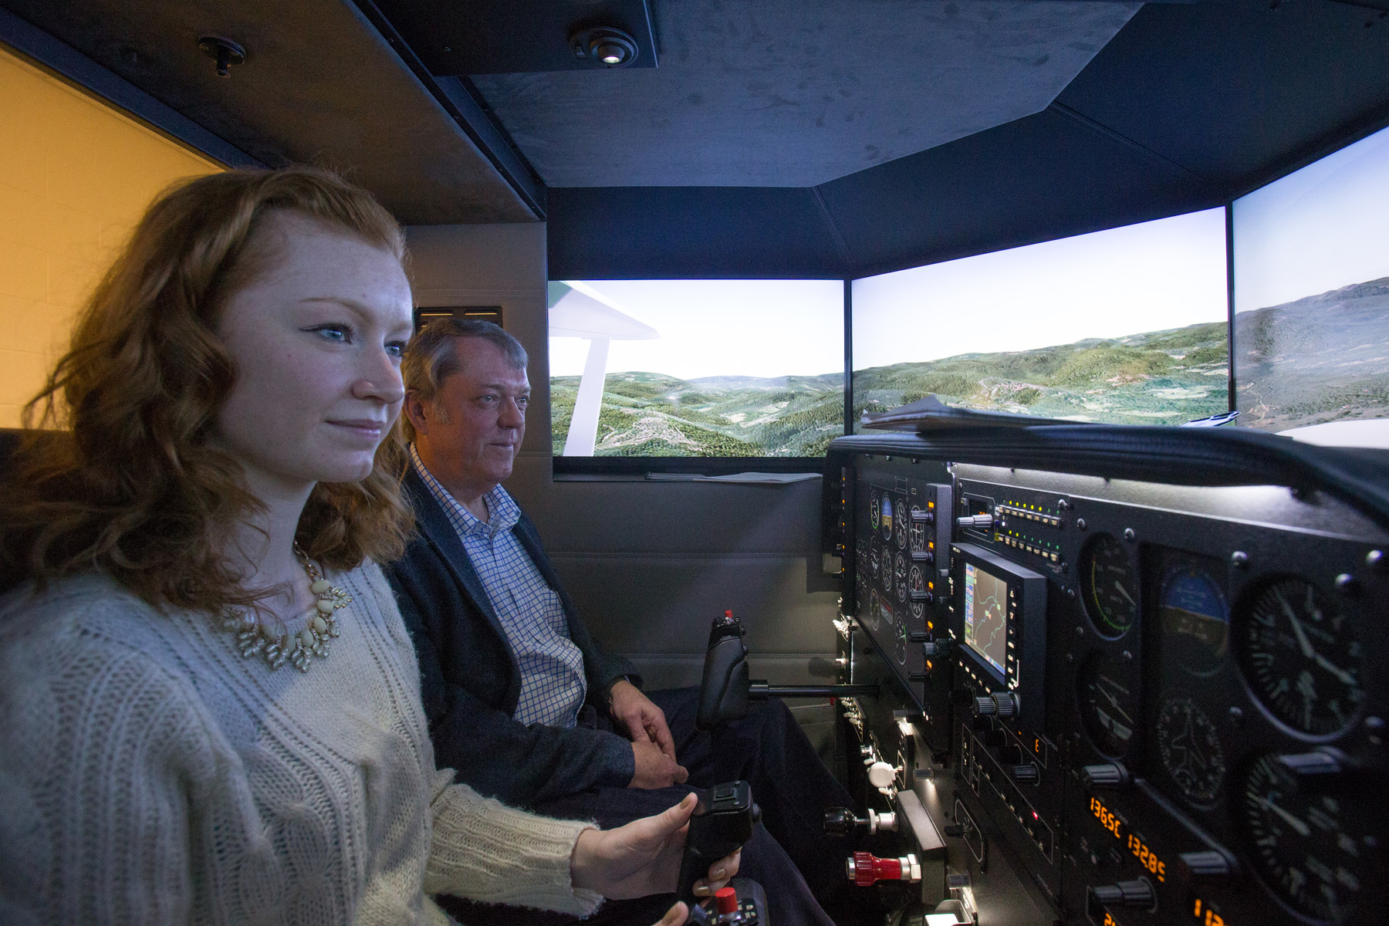

*Figure 3.1.3-1 [1]: Student flight simulator at the University of Virginia*

**3.2 Motion Base Stewart Platform**

The most frequently used method for producing a motion base is the Stewart Platform. A Stewart platform is a mechanical device that uses six actuators and two plates to produce a 6 degree of freedom system. A seat or simulator capsule placed on top of the Stewart platform can be moved in the three linear directions (x,y,z) and the three rotational directions (roll, pitch, yaw) **[3]**. For this reason, the Stewart platform proves exceptionally useful as a motion base for a simulator and is consistently used in industry.

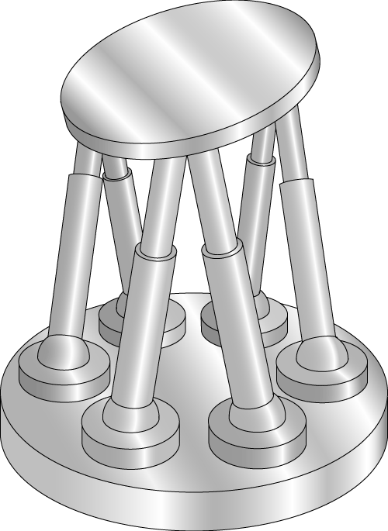

*Figure 3.2-1 [2]: Model of a Stewart platform with two plates and six actuators*

**3.3 Virtual Reality**

For any useful flight simulator, a life like virtual reality package is a necessity. There are a variety of software packages out there that can be used for flight simulation. Some examples include X Plane, Microsoft Flight Simulator, FlightGear, FSX or custom built simulation programs created in house by larger companies. The most important aspect of the virtual reality program, is that the controls inputted by the pilot accurately represent what would happen with a real plane. For most simulator programs, a variety of plane sizes, weights, and locations can be uploaded to practice with different conditions. A good virtual reality program can accurately simulate the effects of turbulence, wind, lightning, power failure, in addition to a host of other external conditions **[4]**. In conjunction with a Stewart platform, an effective virtual reality system can replicate real life flight very closely.

**3.4 Varieties**

**3.4.1 Full Flight Simulators (FFS)**

When an exact replica of a specific plane or other aircraft is required a full flight simulator is often used. These devices are the most expensive of all the flight simulators and require all of the equipment present to fly the actual aircraft, a visual virtual reality system that replicates actual cockpit conditions, and a motion base that provides at least three degrees of freedom **[5]**. These simulators incorporate motion, vibration, sight, and feel into one to provide a cohesive flight experience.

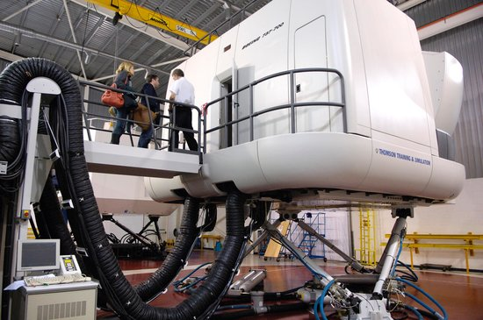

*Figure 3.4.1-1 [3]: Boeing 737-800 Full Flight Simulator*

**3.4.2 Flight Training Devices (FTD)**

A flight training device normally has a full sized replica of the instruments, equipment, and controls of an aircraft, but does not have a motion base **[6]**. Virtual reality software is utilized in addition to vibration and noise systems which help to recreate the “feel” of flight, takeoff, and landing. All of the instruments used in the real plane must be transferred to the FTD simulator.

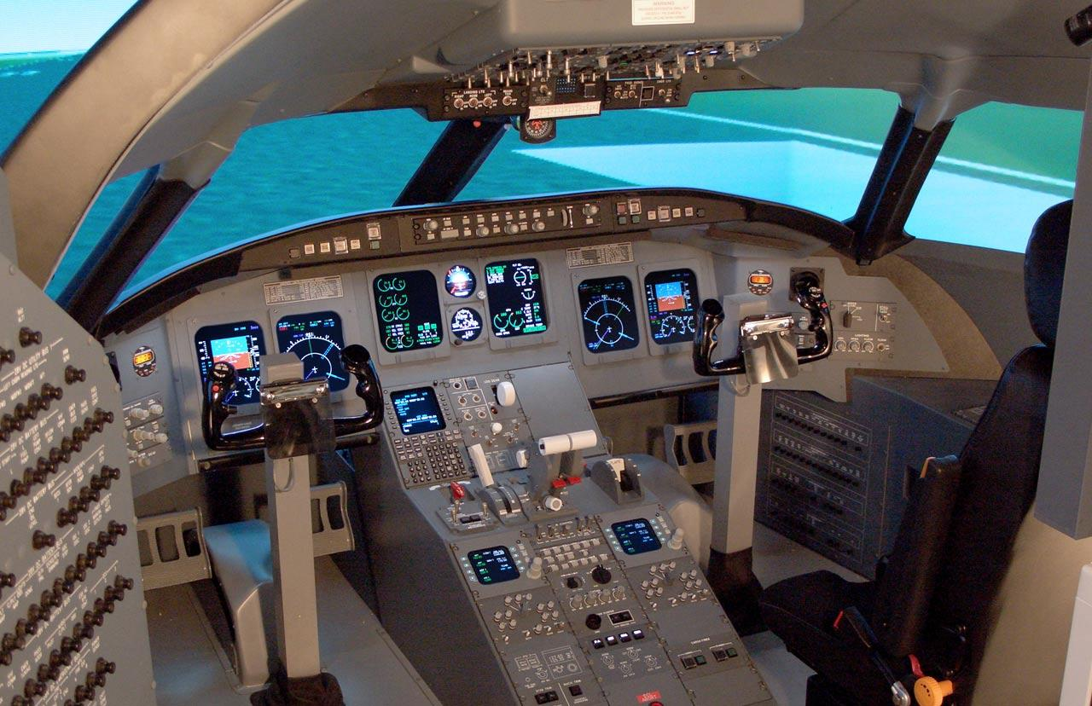

*Figure 3.4.2-1[4]: Frasca Fixed Wing Flight Training Device*

**3.4.3 Aviation Training Devices (ATD)**

An aviation training device is similar to a FTD, but is not required to be a full sized replica **[7]**. It requires the basic controls necessary to fly a variety of different aircraft, and uses a PC based simulation. This is the most basic form of flight simulator used in industry today.

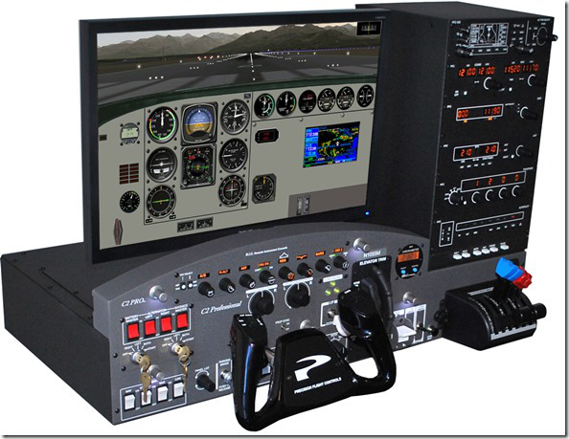

*Figure 3.4.3-1 [5]: ATD manufactured by Precision Flight Controls Company*

**4. PROBLEM STATEMENT AND DESIGN OBJECTIVES**

**4.1 Problem Definition**

The problem this project was seeking to solve was how to connect a Stewart platform to a motion controller. At the start of the project, the Stewart platform at Villanova was connected to a ‘WALDO’. This WALDO is a smaller version of the Stewart and can be manually manipulated. As the WALDO is moved, the actual Stewart platform moves in the same manner. The biggest limitation to this approach was it required the smaller platform to be moved manually. This prevents the main Stewart platform from interfacing with any other type of system. This project aimed to switch the platform over to a method of external, digital control. This way, a user could input flight attitudes, or pre-code a flight profile, and the platform would follow suit, effectively serving as an elementary level flight simulator. To do this, a mathematical model of the platform was devised and applied, so that the platform moved accurately according to prescribed x, y ,z translational directions and roll, pitch, yaw angles. Once the model was developed, a digital control system needed to be developed and implemented so that the model’s mathematical outputs could be fed into the system.

**4.2 Design Objectives**

A few main challenges had to be addressed to accomplish this project. Since the platform was already built, no physical components needed to be implemented. Most of the challenges faced included a mechanical analysis of the system, safety constraints, control tuning, programming, or modeling obstacles. The platform did not need to be tested for functionality.

**4.2.1 Platform Measurement Precision**

The platform’s legs already had sensors that return the leg lengths of each of the six legs. This data needed to be accessed and recorded. However, the x, y, and z positions of the platform itself, as well as the angular velocities about each axis, needed to be collected, so that the geometric transforms could be validated. A potential solution was to use an accelerometer and a gyroscope (or even an Inertial Measurement Unit) to capture the platform’s positions and velocities.

**4.2.2. Mathematical Model**

The second challenge was to correctly model the platform. In particular, a mathematical model that transformed the desired orientation of the platform into six individual leg lengths that yielded the desired platform attitude. One paper (reference [4]) detailed a model using a nonlinear multibody dynamics approach, and made a lot of sense to use. However, another approach, state-space control with disturbance compensation, would have been easier to implement.

**4.2.3 Control Scheme**

Once the mathematical model was decided upon, a control scheme needed to be devised. First, a programming language and CPU-architecture scheme was to be decided upon. Microcomputers and sensors were likely the most ideal to control the platform with, as long as an external computer could handle the more involved calculations. The microcomputer (a Raspberry Pi for example) could have either been programmed with part of the model, or it could have received all the model’s mathematical inputs from an external computer, and then transmitted the data through an implemented algorithm so a displacement control was imparted onto each leg.

**4.2.4 Control Structure**

Once a control scheme had been devised, the structure was to be developed. An open-source structure that used MATLAB, Simulink, and SimMechanics was the leading choice for the control structure. The details of this control architecture will be discussed in the following section. Each leg needed to be provided with a new command at least 10 times per second. Additionally, the control structure had to enable the platform to move fluidly in all six degrees of freedom (roll, pitch, yaw, x, y, z).

**4.2.5 Stewart Platform**

The pneumatic Stewart platform at the start of the project was prebuilt. However, we will still need to determine its mechanical characteristics and perform some modifications to it. The WALDO and the associated wiring needed to be removed from the current platform bases and replaced. In addition an air compressor needed to be secured to the inlet so the platform would be able to run properly. Ideally, a pilot seat and the pilot instrumentation would have been mounted to the platform.

**4.2.6 Control Systems**

The key challenge was to provide the proper commands to the actuator controllers and have the controllers’ PID settings be properly tuned.

In addition to controlling the attitude of the platform, the actuators had a limited length the control system needed to continuously return the platform to the neutral location, at accelerations below the threshold level of human perception When an actuator is near its minimum length or its maximum length, it has little capability to position the platform, therefore, whenever the opportunity exists the control system must try to move the leg length as close to center as possible. This process is called “washout”.

The system was pneumatic, so an air compressor had to be properly sized and added to the system. On the base platform the CPU, required to operate the platform, was mounted. This required wiring between the CPU and the sensors. In addition to the wiring, a power supply was required to operate the electronics.

**4.2.7 Safety Concerns**

The Stewart platform had the ability to make sudden and fast movements which could pose a serious safety concern to someone on it or near it. As part of the design process of the sensors, a limit on the speed, acceleration and jerk of the legs was imposed. This minimized any chance of people being injured. Additional safety measures and cut-offs were also required in the event of a malfunction. It was essential to remove any compressed air, and kill the electricity from the system swiftly so that unforeseen errors did not lead to further consequences.

Besides risk to people, there could have been a risk to the actual platform itself. A stress analysis was completed to calculate the maximum weight the platform could handle. A stress analysis was essential to ensure that the platform could support an effective range of weight on top of the simulator, in the event that an individual may someday utilize the motion base. Also, constraints on the legs were required so they did not move into any combination of leg lengths that would put the platform in jeopardy. In order to protect the platform, a safety profile was put in place to prevent unwanted movement from occurring during operation.

**4.3 Product Design Specifications**

**4.3.1 Objectives**

1. The platform must be able to be able to receive digital inputs.
2. The platform must be able to move safely and not harm anyone on or near it.
3. The platform must have a processor on it in order to convert attitude commands into leg length commands.
4. Have the leg length calculations within a tolerance of plus or minus half an inch.
5. Perform a stress analysis to identify maximum tolerances for the platform.
6. Stretch Goal: Implement washout commands.
7. Stretch Goal: Have the platform able to interface with flight simulator software. The platform must have a processor on it in order to take attitude commands (roll, pitch, yaw, x, y, z) from the flight simulator software, convert the commands to leg lengths and insure that the leg length controller is properly tuned for the purpose.

**4.3.2 Constraints**

1. Speed, acceleration and jerk of the legs cannot be too great as it would compromise the system.
2. Processor must be able to compute results in real time and provide seamless transition between raspberry pi and platform.
3. Air compressor must be able to provide enough pressure to the system.
   1. Need to be held at 90psi
4. Power supply cannot give out without advanced warning.
   1. Controllers need a constant supply of 24V
   2. Kill Switch needs a constant supply of 10V
5. Leg controllers must be tuned properly.
   1. Proportional, Derivative and Force Damping need to match for all legs

**5. Technical Approach and Discussion**

**5.1 Preliminary Design Considerations**

**5.1.1 Leg Controllers**

The platform has been pre-equipped with Bimba SPCS-2 Servo Pneumatic Proportional Control System devices that simultaneously control the compressed air release and offer sensory feedback on how well the cylinder is performing to the prescribed commands (in a closed-loop fashion). The device comes with its own software interface that enable the user to input advanced settings. The gains (both proportional and derivative) can be adjusted, as well as force damping and other properties. These settings enabled the team to adjust rise time of the response, percent overshoot, and tune stability. Since each device came equipped with its own software interface and therefore settings, the team ensured that the parameters for each leg’s control were the same.

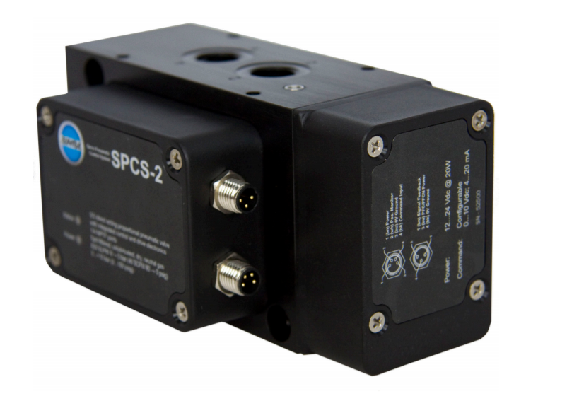

*Figure 5.1.1-1 [6]: Bimba SPCS-2 Servo Pneumatic Proportional Control System*

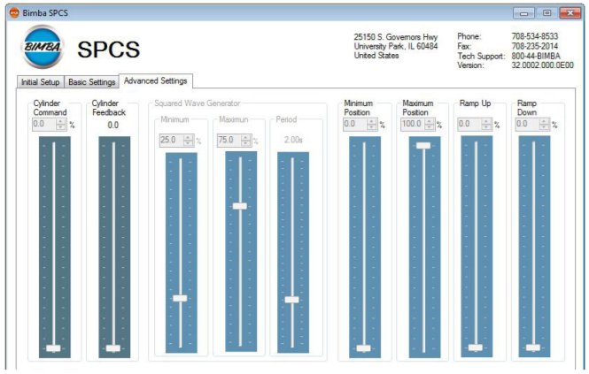

*Figure 5.1.1-2 [7]: The advanced settings software interface of the Bimba SPCS-2*

**5.1.2 Mathematical Model**

The largest challenge modeling the platform arose from the fact that the Stewart platform has 6 degrees of freedom and not 3. In 3 DOF systems, the orientation and translation are co-dependent. However, with this platform, orientation and displacement are independent of each other (e.g. the platform can be at the same angular orientation, albeit at different x,y,z locations.) In order to control the parallel manipulator system, a nonlinear multibody dynamics approach was used. In this model, the generalized coordinates of the platform, the upper legs, and the lower legs, were put into one vector that underwent a series of matrix transformations based on angular displacements in respect to each 3-dimensional axis [4]. These generalized coordinates were coupled with constraints given by minimum and maximum leg lengths, and the rigid platform that held these legs together. Without the constraints, the system could break down (e.g. the computer commands the controller to extend the legs beyond their maximum lengths, and the servo SPCS-2 complies unknowingly).

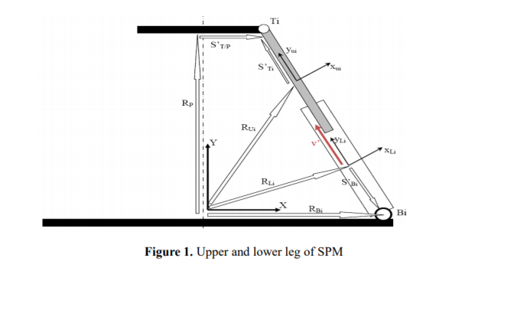

*Figure 5.1.2-1 [8]: Kinematics representations of the upper and lower legs of the Stewart platform model, with corresponding vectors and reference axes.*

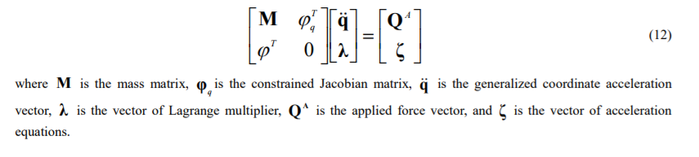

*Figure 5.1.2-2 [9]: Basis of the dynamics approach to the model, after the kinematic analysis has been completed. This equation is used to create the differential algebraic equation (DAE) that will be used in numerical simulation.*

**5.1.3 CPU Architecture Scheme**

The platform’s legs should be controlled by a local computer, or at least some sort of device that can execute code and issue commands (rather than have the platform be controlled completely by an external computer). Ideally, most of the math and control system computing would be done onboard too, so that the flight simulator could be self-sufficient and portable. One potential solution for this problem was to utilize a scheme with six individual Arduino controllers. Each Arduino would receive commands from a central/external computer, solve a given leg length or leg speed, and issue that command to the servo SPCS-2 controllers. Arduinos are relatively inexpensive microcontrollers that can execute code in their own language. Fortunately, this language is open-source, and there are already some models and control algorithms online related to controlling the Stewart Platform. Some downsides of six separate Arduinos involve cost and computing efficiency. If the math and control commands could be done by one central computer, then it may be redundant to outsource the transformations to each individual Arduino. Regardless, this structure would have most likely accomplished the task.

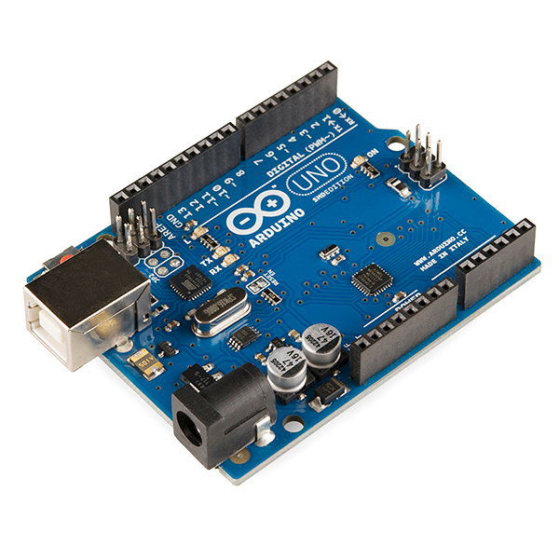

*Figure 5.1.3-1 [10]: Arduino Uno, one of the newer Arduino microcontrollers. One of these would be attached to each leg of the platform, and they would each be controlled by a central computer of some sort.*

Alternatively, a Raspberry Pi, or a microcomputer of a similar sort (e.g. BeagleBone Black, Banana Pi, HummingBoard, etc.), may be able to carry out the mathematical modeling as well as the control commands itself. In this case, the Pi would be wired to the servo controllers directly, and the Pi would receive the primary orientation and velocity inputs. Or, the Pi may be able to be the on-board computer that is attached to the platform, sending signals to six individual Arduinos that execute the controls. This scheme may be more time efficient and yield a quicker and more accurate movement, but it would not be as cost efficient. There were two decisions that needed to be made here: which scheme to use (how many controllers, where to place them and what each will do), and which controllers/CPUs to use.

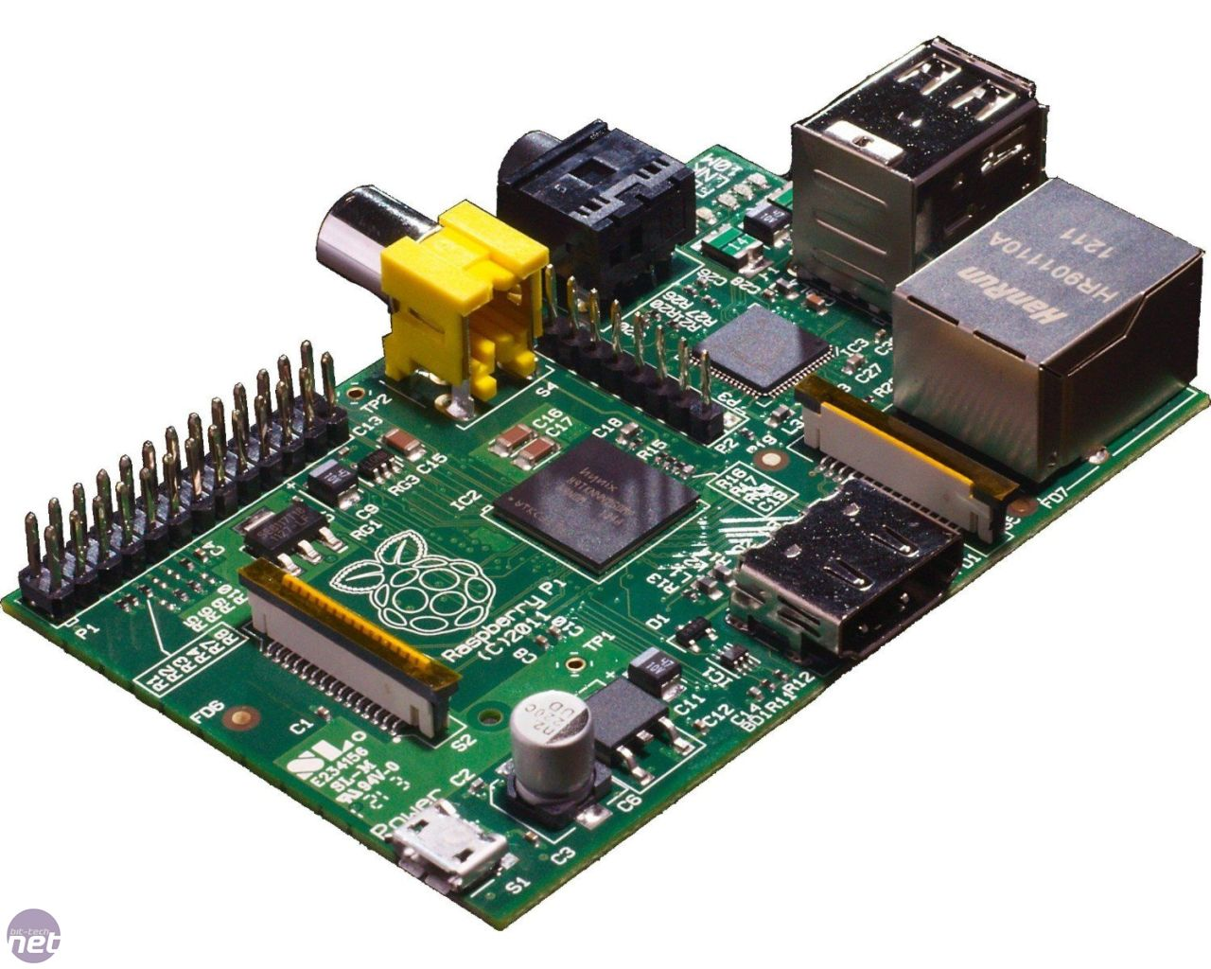

*Figure 5.1.3-2 [11]: A Raspberry Pi single-board computer. One would be placed on the Stewart platform and execute most of the input commands the user types into the computer (before the joystick control kit is assembled). Other single-board computers are open for consideration.*

**5.1.4 Control Structure**

Highly dependent on the control scheme, the control structure is the set of loops, block diagrams, and feedback controls that were used to implement the commands. Open source modeling and control code in MATLAB, Simulink, and SimMechanics exists, and therefore this was the platform the team went on to use. The control system’s plant sends commands to each of the six legs to extend to a certain length. The SPCS-2 sensors provide feedback to the system, and the controller uses a PID compensator to adjust for any discrepancies. Additionally, a reference trajectory (i.e. the overall geometry of the platform in addition to the initial leg lengths) needed to be programmed into the control loop, since the provided open source code was in generalized form. The code could then be applied to Stewart platforms of various geometries and sizes, so it was important that the code recognize this platform’s exact geometry. The PID gains needed to be adjusted, but the existing code gave recommended gains that served as good starting points. The code also had to be tinkered and changed depending on the system architecture and type of CPU the team will use. Also, in order to use this code, the CPUs and microcontrollers needed to be compatible with MATLAB and Simulink, or at least easily transformable.

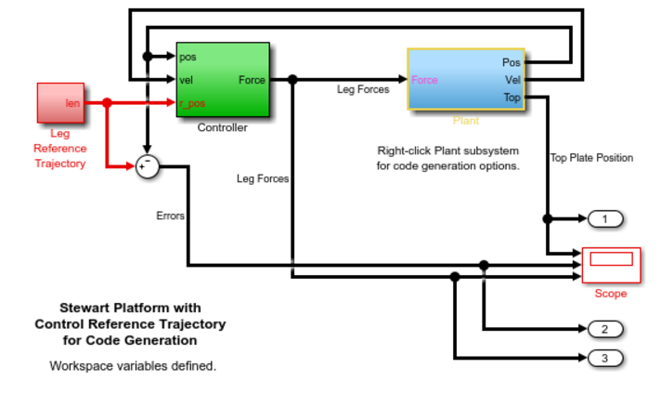

*Figure 5.1.4-1 [12]: The entire platform control system overview. On the left is the leg reference trajectory, which is devised based on this specific platform’s geometry. The Plant (shown in Figure 2.4.5-2 below) is what imparts the control commands to each leg to displace a certain distance. The controller is what takes in the error and compensates for it using specific PID gains. This will adjust the force inputs to the plant, so that the output positions and velocities are as desired.*

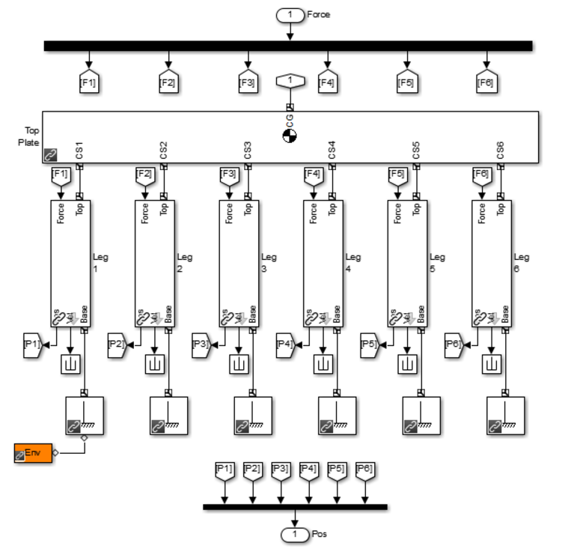

*Figure 5.1.4-2 [13]:The control Plant subsystem that incorporates the platform in the model, along with the six legs. As can be seen, each leg is attached to ground. Each leg also receives one force input, and outputs its own position, eventually leading to a specific position of the platform detailed by all six legs’ lengths.*

**5.1.5 Central Computer**

**5.1.5-1 Raspberry Pi**

Raspberry Pi is a single board computer developed out of the UK. It is cheap and very easy to use. It is mostly used by beginner Computer science and coding enthusiasts. Raspberry Pi depending on the seller are around $35.

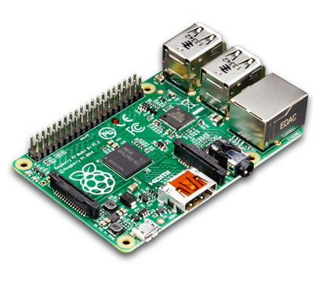

*Figure 5.1.5-1 [14]: Raspberry Pi*

**5.1.5-2 Minnowboard**

Minnowboard is a stronger and more complex version of the Raspberry Pi. Meant for more intermediate users, it is a high performance, open platform system with lots of freedom for customization. Minnowboard depending on the seller are around $150.

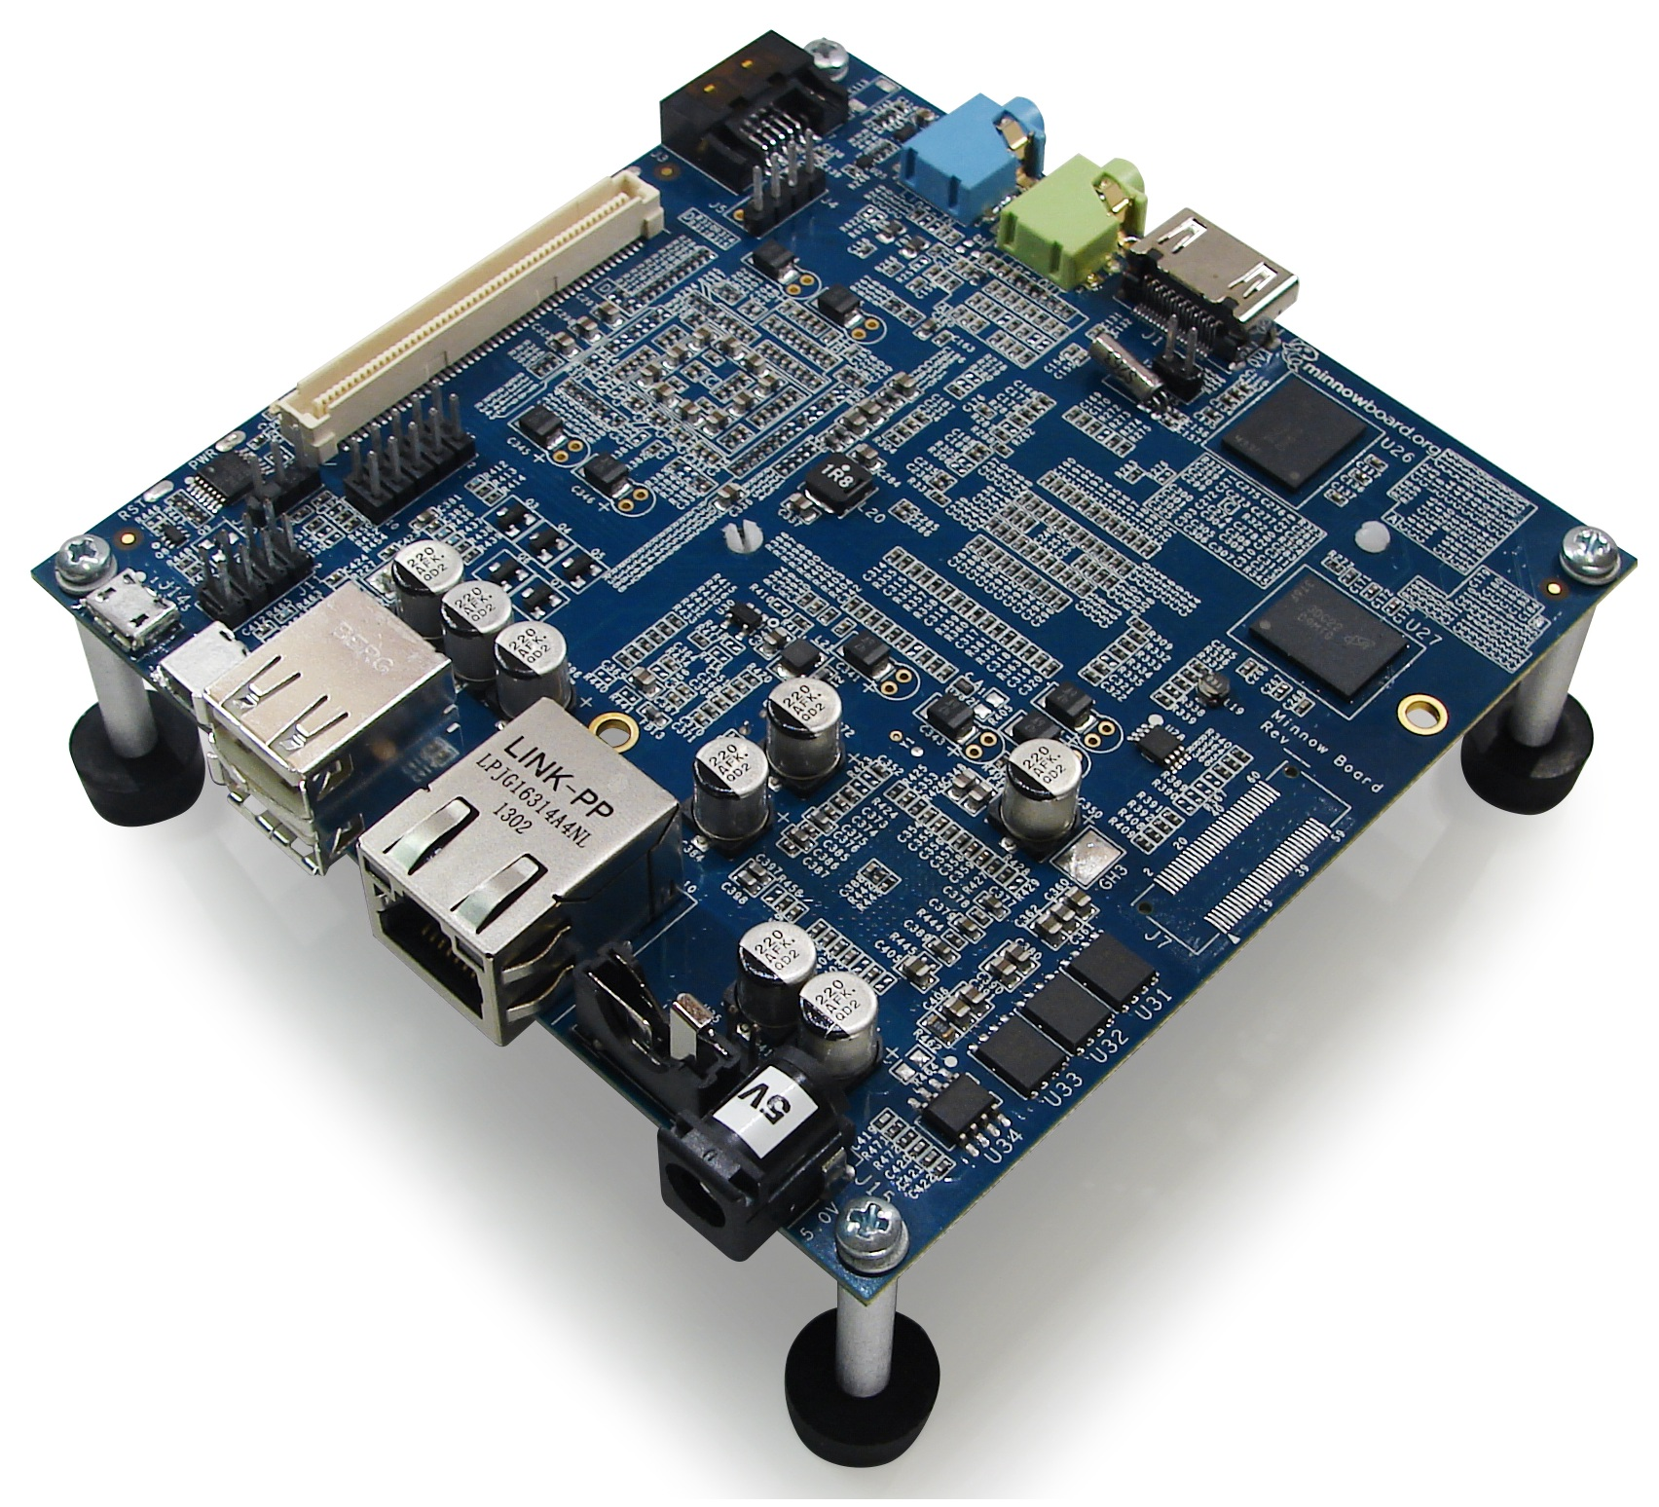

*Figure 5.1.5-2 [15]: Minnowboard*

**5.1.5-3 Radxa Rock**

Radxa Rock is very comparable to both the Raspberry Pi and Minnowboard. Has ease of use like the raspberry pi, but also has lots of more complex qualities like the minnowboard. This system is for the beginner-immediate user. Radxa rock depending on the seller are around $100.

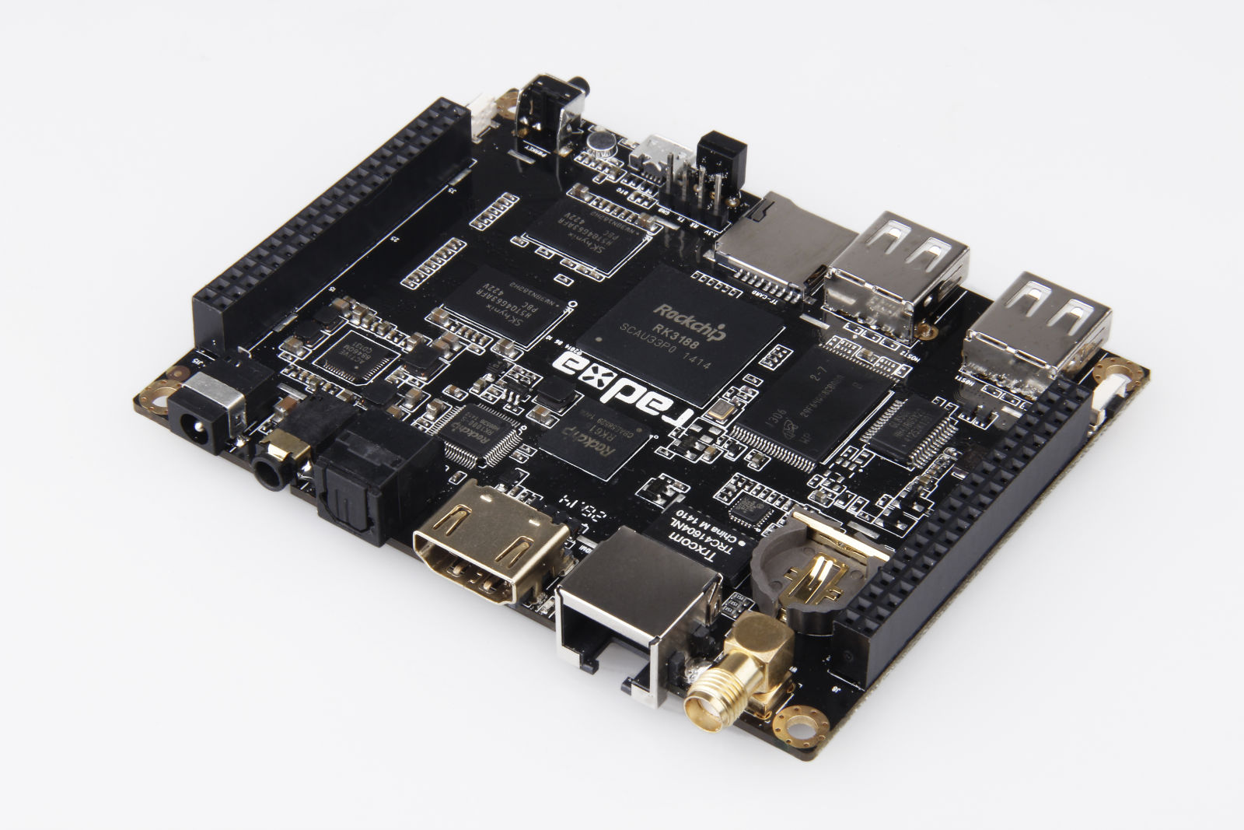

*Figure 5.1.5-3 [16]: Radxa Rock*

There were not many decisions to start with when beginning this project. The group was given the Stewart platform and asked to design a remote control for it, along with the possibility of running a simulation with it. The two biggest design choices were: choosing between Arduinos or one central computer, and between coding with MATLAB or another source of code. Both of these decisions were very simple and easy to make. The decision process is discussed below.

**5.1.6 CPU Evaluations**

There were not many decisions to start with when beginning this project. The group was given the Stewart platform and asked to design a remote control for it, along with the possibility of running a simulation with it. The two biggest design choices were: choosing between Arduinos or one central computer, and between coding with MATLAB or another source of code. Both of these decisions were very simple and easy to make. The decision process is discussed below.

The biggest design decision for this project was to figure out how we wanted to send signals to the platform. It came down to picking between 6 Arduinos (one for each leg) or one central computer. Now sending signals to one computer, that sends the signals out to each of the legs is much easier than send separate signals to each Arduino on each leg. So we decided to move forward with the central computer. Even though the central computer is more expensive, it is worth the expense to ease the system. The decision matrix detailing the pros and cons of each CPU is shown below.

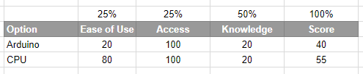

*Table 5.1.6-1: Decision Matrix for Arduino vs CPU*

|  |  |  |  |
| --- | --- | --- | --- |
| **Central Computer Options** | **Figure** | **Pros** | **Cons** |
| Raspberry Pi | 5.1.5-1 | - A well-specified single-board computer for engineers, makers and experimentalists of all ages  - Several operating systems are available  - Includes a good range of educational application software | - Requires various additional items before it’s ready to run  - The Raspberry Pi must be programmed with a chosen operating system before it’s ready for use  - Default overscan allowance results in an unused border on many monitors |
| Minnowboard | 5.1.5-2 | - Other than releasing all drivers as open source, Intel has also made the schematics of the board available to download, this way hackers can give it a try and build anything they want without restrictions.  - The MinnowBoard Max has 2 USB ports, one of which is a USB 3.0. | - Because it has only two USB ports, one of which to be used for charging, a multi-USB hub is needed to connect a keyboard and mouse which are the absolute minimal external devices to be able to use and configure the MinnowBoard.  - Although this is not the board's fault per-se, no official OS image has enabled support for GPIO. But if the kernel is compiled from source, it can be compiled with GPIO and PWM enabled. |
| Radxa Rock | 5.1.5-3 | - Runs a Cortex A9 Quad Core processor, 2 gigabytes of ram and a 8 gigabytes NAND. It comes with WiFi, Bluetooth, IR remote, a GPU and other perks already installed and running.  - Portable and easy to use.No learning curve needed, just start up and connect. | - Slow processing when memory is close to maximum use.  - Complaints that system dies much faster than other models |

*Table 5.1.6-2:Pros and Cons of Central Computers*

After the benefits and drawbacks of each respective central CPU were explored, our final design choice was to use a Raspberry Pi. The Pi proved the most accessible CPU available, since the MDL already had Pi’s available for use, in addition to SD card, Linux-core operating systems. The lack of a pre-equipped OS was the biggest con for the Pi, and this accessibility virtually eliminated that negative quality. In addition, the Pi runs well with Python code, as well as I2C connection capabilities, which the team’s coding members have prior experience with. Therefore, it was determined a Raspberry Pi would prove the easiest to apply to the platform and process digital inputs.

**5.1.7 Coding Software**

The coding software the group decided on using for this project is Python. Python operates extremely efficiently with the Raspberry Pi, and was significantly easier to interface than MATLAB. Although the majority of the groups expertise was with MATLAB software, the challenges of implementing MATLAB code with the Pi were too cumbersome. As a result, it was determined that the most effective option would be to improve the teams Python coding skills and experiment through trial and error.

**5.2 Design Tasks and Scheduling**

The following tasks were completed in order to achieve the proposed project design and goals:

1. Weekly meetings
2. Research existing Stewart platform
3. Purchase parts
4. Remove WALDO
5. Tune Leg Controllers
6. Install Safety Measures
7. Configure CPU
8. Perform MATLAB Leg Length Calculations
9. Write preliminary test code for platform
10. Write final flight profile

**5.3 The Final Design**

**5.3.1 Removing WALDO**

The WALDO, shown in Figure 5.3.1-1, was a smaller version of the larger Stewart Platform. As the user would move the WALDO, voltage would be sent from the power source to the controllers to mirror the position of the WALDO. Before removing the WALDO, it was imperative that the wiring sent to each leg was labeled correctly. To ensure this was true, the top of the Stewart platform was removed briefly, then each leg was tested separately. Once the wiring was labeled correctly and confirmed, the WALDO could be removed. The wiring hardware was reused for the new Raspberry Pi, as shown in Figure 5.3.1-2.

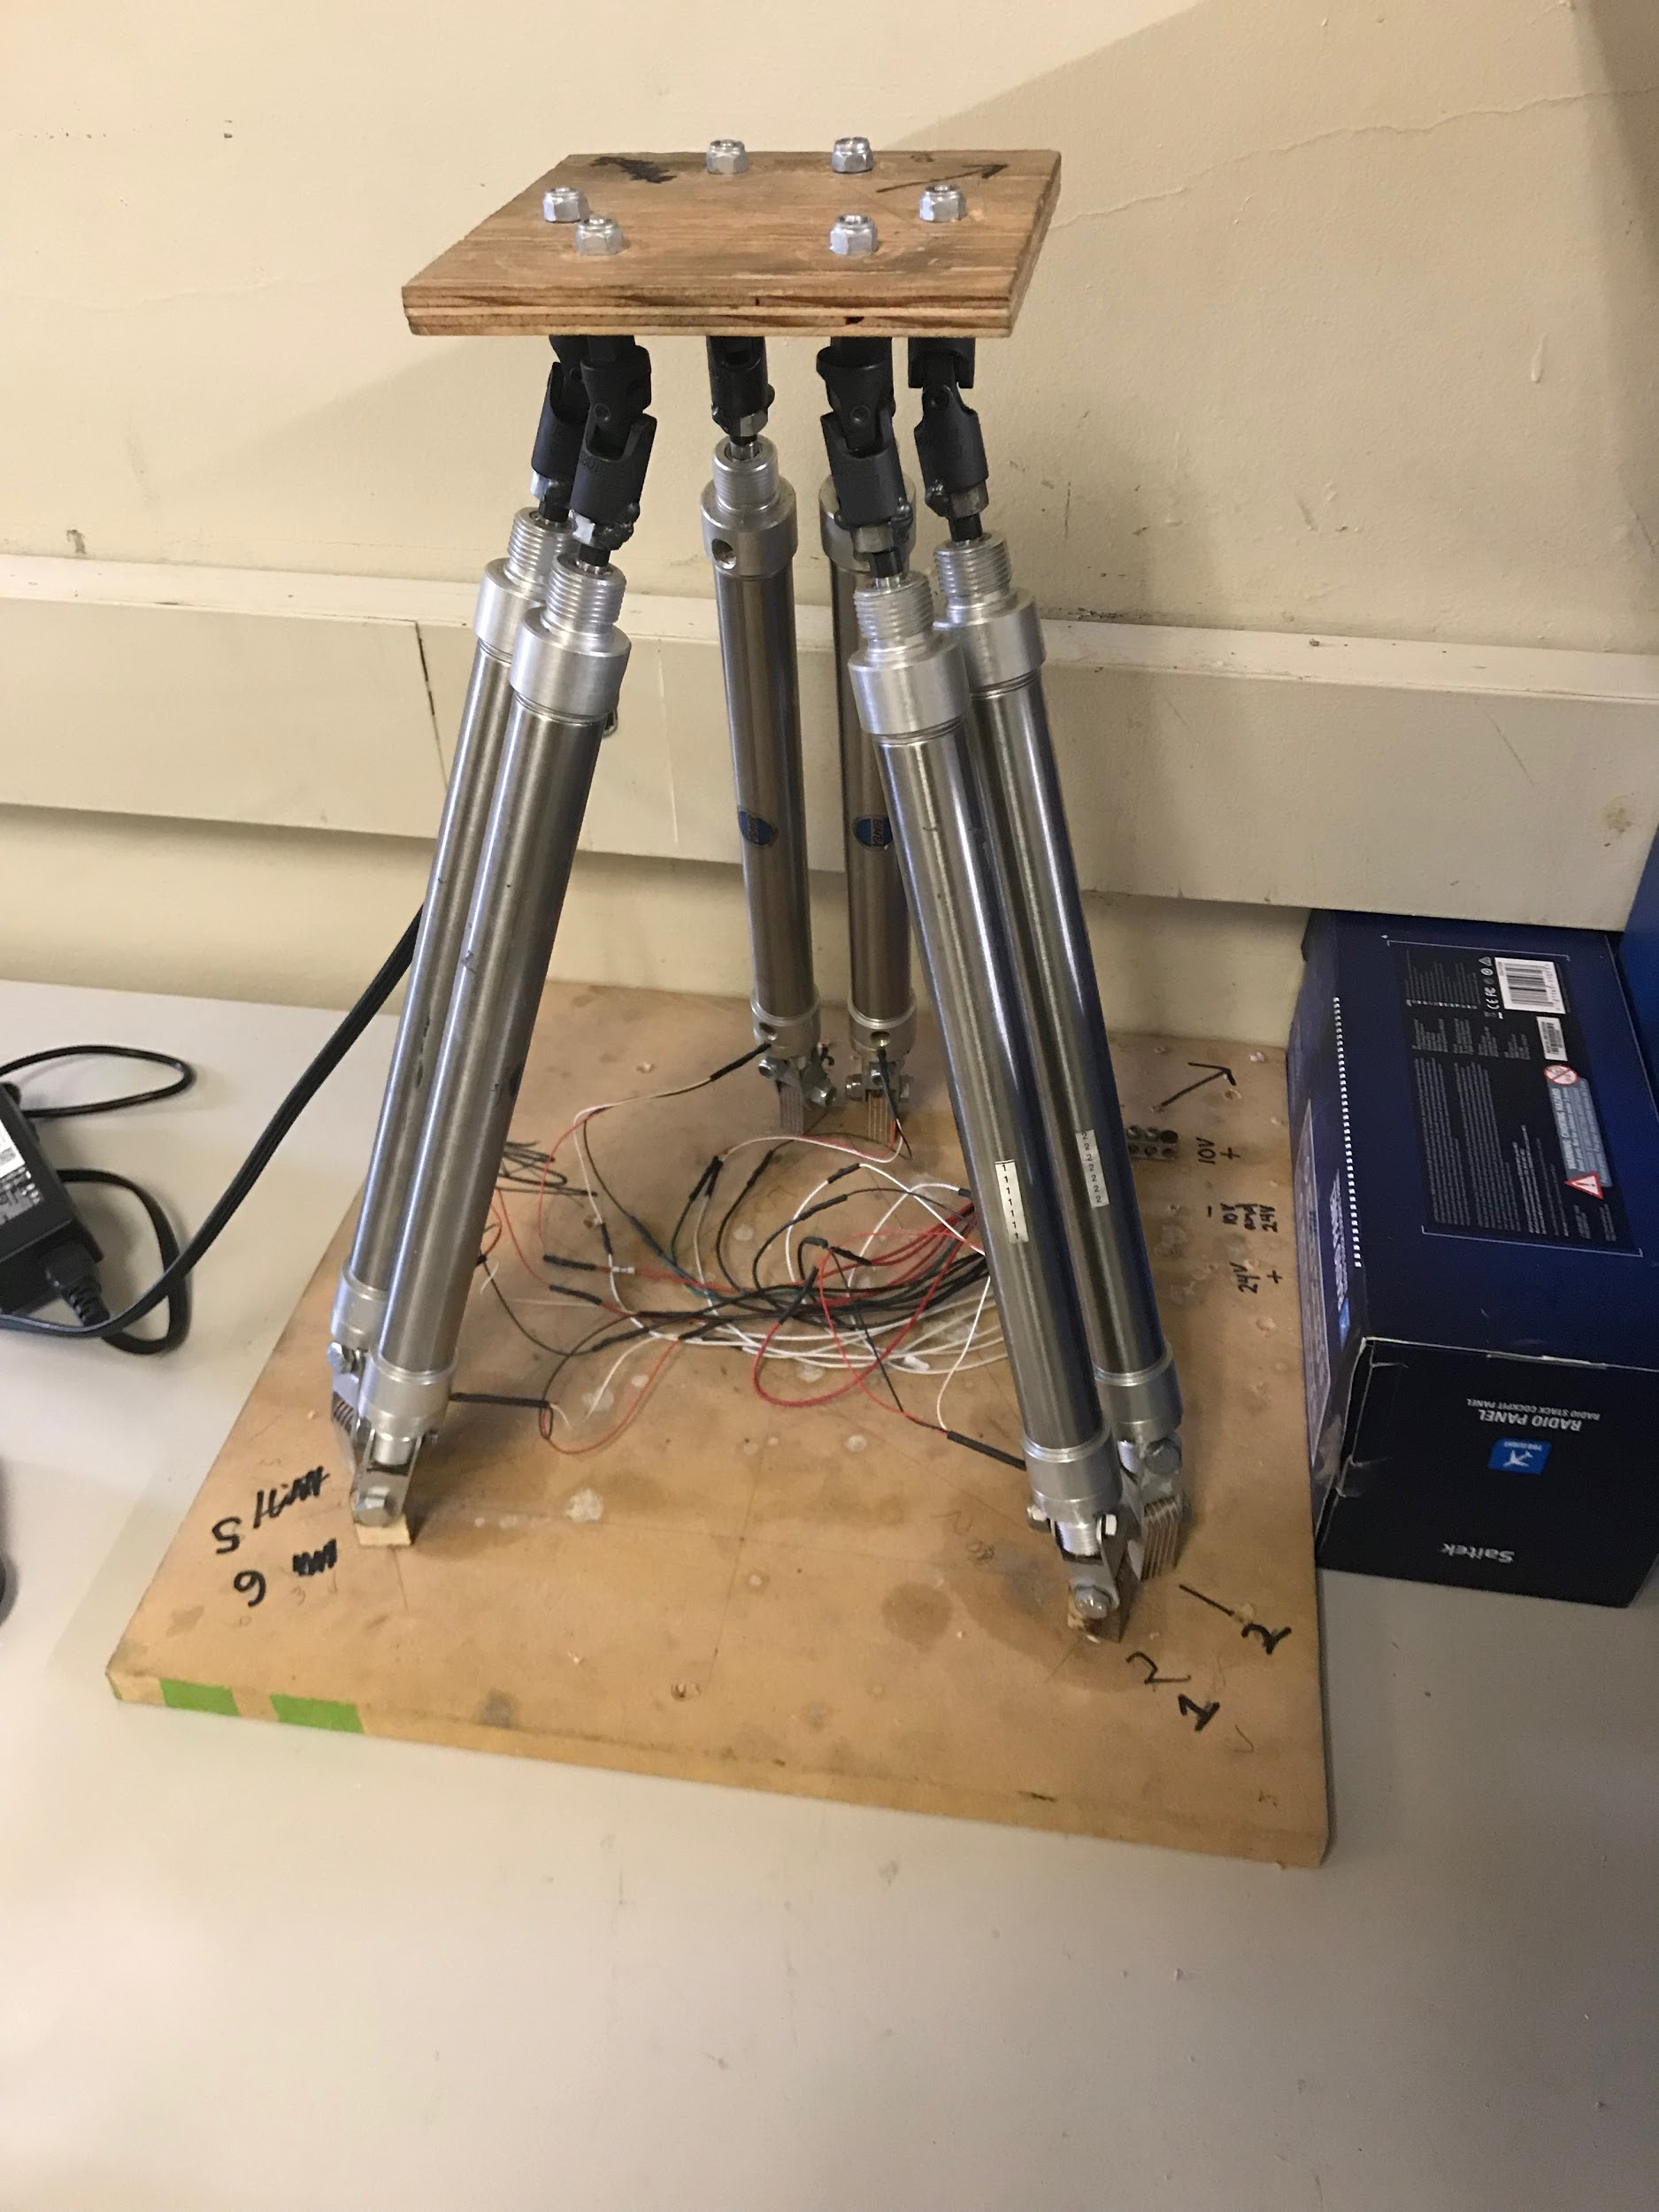

*Figure 5.3.1-1 [17]: WALDO*

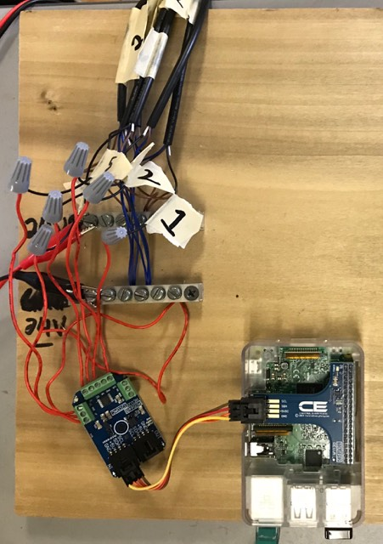

*Figure 5.3.1-2 [18]: Reused Wiring Hardware Connected to Raspberry Pi*

**5.3.2 Installing Safety Measures**

The biggest concern for this project, and in most projects, is safety. There was one safety measure already in place at the beginning of year, and that was the kill switch. The kill switch, shown in Figure 5.3.2-1, is initiated by pressing the button in the top left corner, which activates the hardware in the bottom right corner that cuts off all air entering the Stewart platform. This is not effective on its own, due to the fact that there is still air within the system. So more safety measures needed to be put in place.

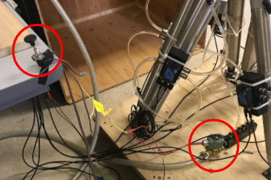

*Figure 5.3.2-1 [19]: Kill Switch*

The next safety measure that was put into place, was the pressure release valve. The pressure release valve, shown in Figure 5.3.2-2, was used to remove all the air in the system. Once the kill switch is activated and the pressure release valve would be opened, allowing all the air to be removed from the system. This was a more effective of killing the system, but did not kill it completely.

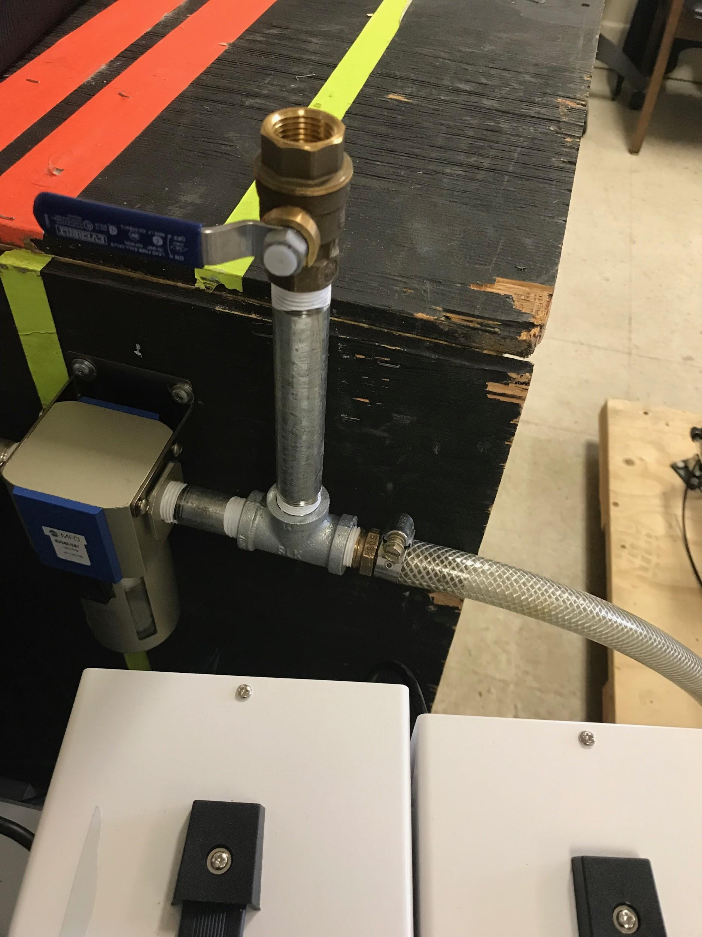

*Figure 5.3.2-2 [20]: Pressure Release Valve*

Lastly there was one more safety measure put in, and that was a power kill switch. The first two measures solves the air being sent to the system, and the power kill switch deactivates the platform entirely. All the power supplies are plugged into one power strip, and this would be turned off. Turning the power strip off would kill all the power running to the platform.

All of these safety measures combined, allows the user to safely turn off the entire system, if someone were to eventually sit on top of the platform. Moving forward, it would be wise to combine all these measures into one central kill switch. For now, the three separate measures work well.

**5.3.3 Tuning Leg Controllers**

One of the most critical criteria for the design of the flight simulator motion base is smooth motion from the pneumatic legs. In order to recreate a realistic flight profile it was necessary to completely eliminate any rigidity or unwanted rapid movement from the simulator legs. To accomplish this, the Bimba SPCS leg controller software was utilized to modify the PD control values for the system, and to identify the values most appropriate for smooth and balanced cylinder actuation.

**5.3.3-1 Bimba SPCS Software**

The Bimba SPCS Software was essential for the proper set up and calibration of the Bimba servo pneumatic controllers. The system operates within a voltage range of 0-10 Volts via analog signal, and provides closed loop pneumatic feedback PD control for the Bimba pneumatic actuators utilized in the motion base. Utilizing the software, a variety of values can be modified but only a few were essential to be modified for the project application. For initial testing, the focus was on analyzing the Proportional, Derivative, and Force Damping responses of each controller. Utilizing the software a variety of inputs including step, triangle, square, and sine wave can be inputted to analyze how the controller and leg would respond. The robust capabilities of the software enabled precise calibration and allowed the team to quickly and efficiently tune each leg individually.

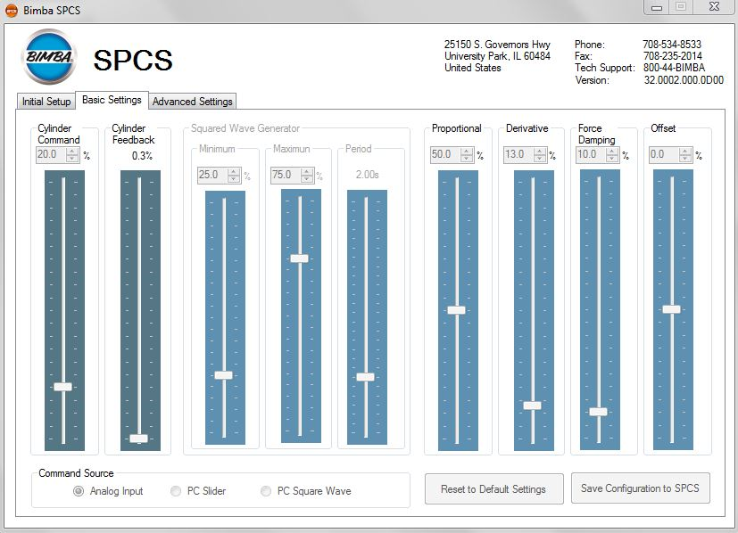

*Figure 5.3.3-1 [21]:Bimba SPCS Software Settings Screenshot*

**5.3.3-2 PD Control**

Proportional-Derivative (PD) Control combines proportional and derivative control in parallel through a process called feedback control. When a setpoint voltage is inputted to the system via the leg controllers, the controller obtains a process variable or present voltage, which determines how far apart the setpoint and process variable are from one another. Depending on the degree of error between the setpoint and process variable, a control output is produced and either more air is provided to the system or air is removed from the system to bring the setpoint and process variable closer to one another.

To calculate the proper control output however tuning constants are required to calculate the amount of voltage and air necessary to reach the setpoint efficiently and smoothly. The first constant used is called the proportional constant. The proportional control mode is the main driving force for the controller and changes proportionally to the degree of the error as the name suggest. This means that if the error is greater, the proportional gain is greater and vice versa. Calibrating the proportional controller gain effectively is essential because if the controller gain is set too high, the system may begin to oscillate and become potentially unstable **[17]**. If the controller gain is set too low, the system won’t respond quickly and efficiently to disturbances or rapid changes in set point.

Derivative control is the second constant that needs to be fine tuned to ensure a smooth system response. Derivative control is used to provide a crude prediction about the systems error in the future based on the errors current trajectory. Once the error has been estimated, a constant is calculated which is equal to the controller gain multiplied by the projected error. Derivative control allows a system to respond smoothly and effectively to rapid changes in a system that occur consistently. Additionally, it makes the feedback loop of the system more stable to a point which allows a higher proportional gain to be used. The derivative gain allows the system to respond quicker to a disturbance which is essential for the precise control we are attempting to recreate.

**5.3.3-3 Controller Tuning Process**

The first step in tuning the controllers was to connect a computer running the Bimba SPCS software, and connect the computer to one of the leg controllers via USB wired connection. Unfortunately, each leg was required to be properly calibrated individually, so care needed to be taken to ensure that each leg was functioning effectively. To test the damping and response of the controller and pneumatic actuator, a 2.5 Volt sine wave was inputted to the controller via the Bimba SPCS software. Utilizing trial and error of different values for the P-control, D-Control, and force damping, optimal values were obtained for each controller that provided a visually appealing and smooth response to the sine wave input.

Determining the proper control values individually for each leg proved to be essential, because as legs were tested it became clear that not all leg controllers or legs responded identically to the same control values. Each leg had independent PD values, that although similar, were not exactly the same. This testing and observation helped to create a significantly smoother motion base response and enabled more aggressive flight profiles to be inputted to the system without fear of catastrophic leg failure or response.

**5.3.4 Control System Installation**

**5.3.4-1 Raspberry Pi**

After removing the WALDO, installing the necessary safety measures, and properly tuning all of the leg controllers, the central CPU was finally able to be installed. As decided upon using the decision matrix in section 5.1.7, a Raspberry Pi was selected to be the central computer due to its ease of use, cost, and reliability. In order to set up the Raspberry Pi several other pieces of equipment were required to finalize the hardware requirements for the system. The equipment used includes

* Bluetooth Mouse and Keyboard
* HDMI Compatible Monitor
* 6 ft HDMI Cable
* Raspberry Pi Protective Case
* Wood slab for equipment mounting
* 12 ft Ethernet Cable
* I2C Port Adapter for Raspberry Pi
* Digital Analog Converter 8 port Mini Module
* Wiring

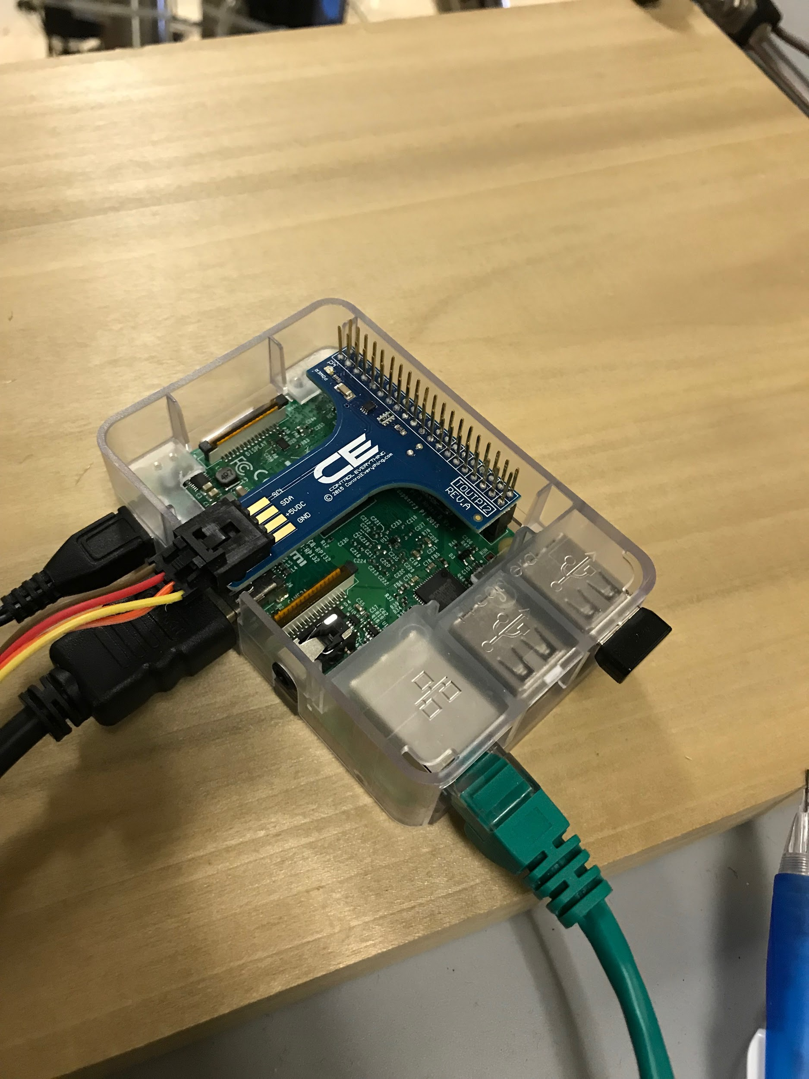

*Figure 5.3.4-1 [22]: Raspberry Pi with all wired and Bluetooth connections equipped*

After placing the Raspberry Pi in its protective casing, the HDMI, Ethernet, Bluetooth USB, and Pi power source needed to be hooked up. Once powered on, and connected to the internet Python could be accessed and code sent digitally to the Pi. An essential attachment to the Raspberry Pi however was the I2c adapter which enabled the daisy chaining of a digital analog converter chip. The adapter seen in blue in image 5.3.4-1 above enabled an I2c cable to connect to the DAC which would eventually be wired to the motion base pneumatic controllers.

**5.3.5-2 Digital Analog Converter**

The digital analog converter proved to be one of the most essential pieces of equipment utilized in the motion base system. Since the Bimba pneumatic controllers could only be powered by analog inputs (voltages), it was essential to be able to translate digital Python code inputted to the Raspberry Pi into analog signals that could be read by the controllers. In order to send signals to 6 individual controllers simultaneously, it was vital to acquire a DAC chip capable of handling at least 6 communication ports.

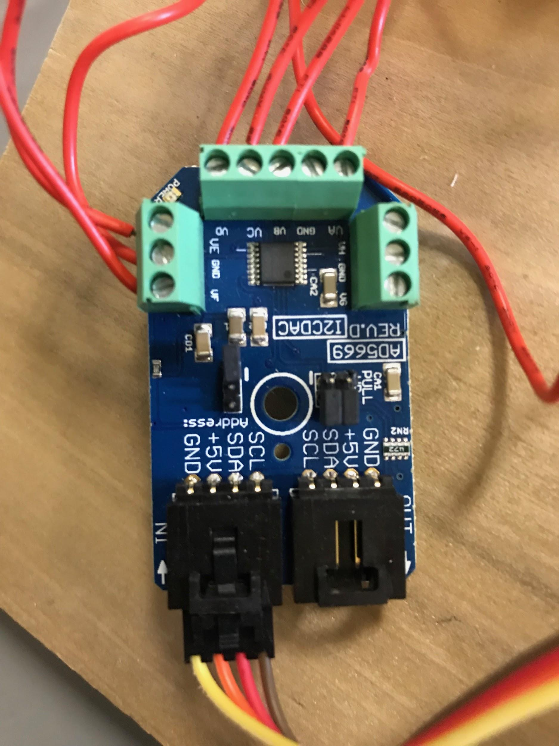

*Figure 5.3.5-2 [23]: Digital Analog Converter chip with wired connections to each of the 6 leg controllers*

As seen in image 5.3.5-2, the Digital Analog Converter chip was connected to the Raspberry Pi via the I2c cable and the I2c adapter. Once daisy chained to the Pi, the wiring leading to the controllers could be connected to the DAC to send analog signal, converted from digital Python code to the system. The DAC purchased had 8 ports that could be used for outputting the analog signal which exceeded our demand for 6. From the left green terminal, controllers 1 and 2 were connected, with a third wire leading to to ground. From the center green terminal, controllers 3 through 6 were connected, with an eighth and final wire leading to ground.

To complete the circuit as seen in image 5.3.5-3, ground wires from the sensors pictured in blue were attached to a metal block along with the other two ground wires from the DAC. The metal block was then fed to the ground terminal of the local power source. Additionally, brown wires from the controllers were connected to a metal block, and then connected to the positive terminal of the power source which outputted 12V to power on the controllers. Once all wires were connected the circuit was complete and digital Python code could now be sent to the controllers via digital to analog conversion.

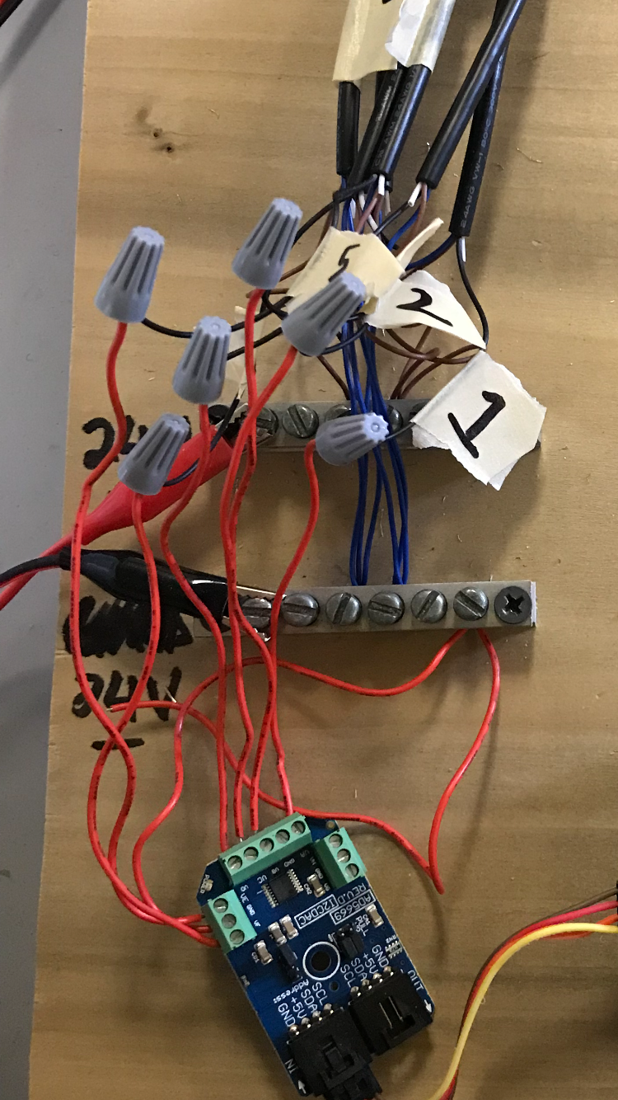

*Figure 5.3.4-3 [24]: Complete wiring setup from DAC to leg controllers, and with metal blocks for ground and positive terminals*

**5.3.5 MATLAB Mathematical Model**

In order for the code to be developed for the platform, it was critical for the leg lengths to be accurately calculated. To do this a mathematical model was developed using an inverse kinematic approach. An inverse kinematic approach means that the desired x,y,z and roll,pitch yaw values are already known. However the leg lengths for the platform are unknown. After looking at a series of possible ways to tackle this problem, it was ultimately decided to use a combination and MATLAB and Simulink to solve the math.

**5.3.5-1 MATLAB Code**

Our research into this led to a mathworks article (reference 3) which contained various MATLAB files as well as a simulinks model. The MATLAB files created the geometry values which would then be executed in the simulinks. The first step of the process was to insert the platform geometry into the file. The file already had a default geometry inserted into it. This included parameters such as height of the base off the group, maximum extension of the legs, lengths of the actuators and the angles the legs and the base formed. The more accurate these values were measured, the more accurate the computed leg lengths would be. This setup code is attached in the appendix below.

**5.3.5-2 Simulinks Model**

Provided with the MATLAB code was a Simulink model which provides a simulation for the entire platform. Instead of focusing on the entire platform, the decision of was made to look at the leg trajectory section of the code.

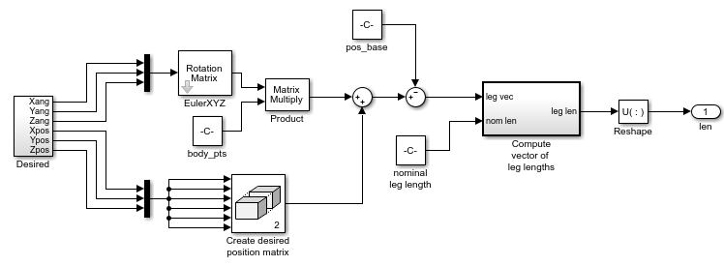

*Figure 5.3.5-1 [25] Simulink Model of the Leg Trajectory section*

The figure above demonstrates how the leg lengths would be calculated. The desired x, y, z and roll, pitch and yaw angles were entered into the desired matrix. Which can be seen in the figure below. This matrix allowed the user to enter the angles in degrees and the x, y, z positions in inches. This allows the most accessible use of the program. These values are then converted into radians and meters as that is what the code requires to run properly.

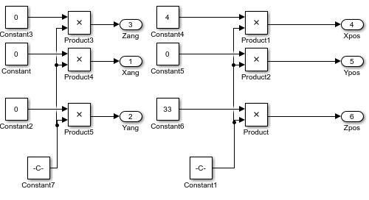

*Figure 5.3.5-2 [26]: Desired Matrix in Leg Trajectory Simulink Model*

Once the desired inputs are entered the values go to two separate places, either the rotation matrix or the position matrix. The rotation matrix computes the new angles the platform must go to. The position matrix calculates the new values of the origin position of the platform to where it will need to go. Finally, these are combined together into the leg length vector matrix. In the leg length vector matrix shown below, the leg lengths that are required to reach the desired position are printed in inches.

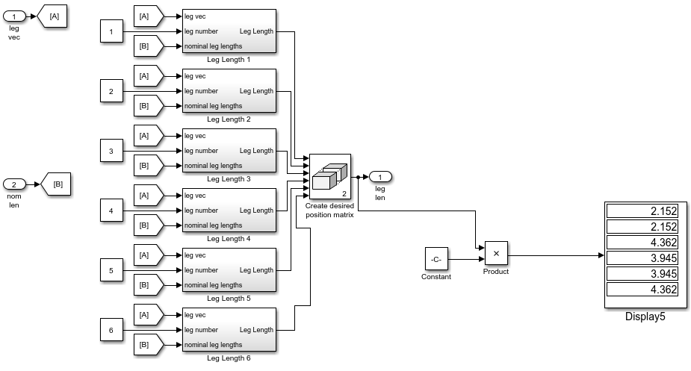

*Figure 5.3.5 -3 [27]: Leg Length Vector Matrix in Leg Trajectory Simulink Model*

These lengths were then entered into the Python code to move the actual platform to the original desired position. Below are the calculated leg lengths to move it in a variation of different desired positions

|  |  |  |  |  |  |  |
| --- | --- | --- | --- | --- | --- | --- |
| Desired Potion | Leg Length 1 (inches) | Leg Length 2 (inches) | Leg Length 3 (inches) | Leg Length 4 (inches) | Leg Length 5 (inches) | Leg Length 6 (inches) |
| 4 inches in X direction | 2.152 | 2.152 | 4.362 | 3.945 | 3.945 | 4.362 |
| 4 inches in Y direction | 3.252 | 3.744 | 2.462 | 2.209 | 4.744 | 4.506 |
| 4 inches in Z direction | 3.272 | 3.272 | 3.272 | 3.272 | 3.272 | 3.272 |
| 20° Roll | 2.370 | 4.157 | 4.421 | 3.486 | 3.082 | 2.234 |
| 20° Pitch | 2.571 | 2.571 | 2.857 | 4.446 | 4.446 | 2.857 |
| 20° Yaw | 2.965 | 3.693 | 2.965 | 3.693 | 2.965 | 3.693 |

*Table 5.3.5-1 - Desired position and the required leg lengths computed by the MATLAB and Simulink model*

**5.3.6 Initial Test Code**

In order to establish communication between the Raspberry Pi and the platform, a test code had to be developed. This code would ideally be able to send rudimentary commands to the SPCS leg controllers, which would move the legs of the platform. First, all legs would be tested at the same time. Then, the platform would be disassembled and each leg of the system would be tested individually, so that the Pi could be proved to send individual commands to each leg.

The language employed was determined to be Python, mainly for ease of use with the Raspberry Pi’s operating system. For a Linux-based operating system (Raspbian), Python code can be edited and executed easily within the command line. Though beginning as a basic code to test functionality, the Python code would eventually be developed to receive commands from the MATLAB math model, and impart those commands accurately to the leg controllers, which would in turn move the legs. Therefore, this Python script is integral to the system’s operation.

**5.3.6-1 Signal Communication with Leg Controllers**

At this point, the team ran into what was probably the largest and most difficult obstacle to overcome. It was discovered that the SPCS Controllers were designed only to receive analog commands. When the platform was given to us, this was not known--it was expected that switching to digital commands would be fairly straightforward. Now, however, that goal would become much more difficult to achieve, since Bimba was consulted, and they said that it was impossible to have the controllers receive any sort of analog commands. There were two options: one, to reverse engineer the USB protocol of the controllers so that they received analog commands, and two, to simply convert the MATLAB’s digital commands into analog commands through an external DAC, and impart those commands to the controllers. Given the team’s limited experience with heavy sensor communication coding, the second option seemed more appealing, and proved more feasible.

In order to convert the digital signals to analog signals, a DAC card was hooked up to the Raspberry Pi, and had to be wired and coded accordingly. The DAC card was chosen specifically because of its compatibility with the Raspberry Pi 3b. Called a AD5669 16-Bit 8-Channel Digital to Analog Converter, this DAC card had a corresponding adapter, so as to hook up to the Pi and make the pinout wiring easier. Images of the DAC card and the adapter are shown below.

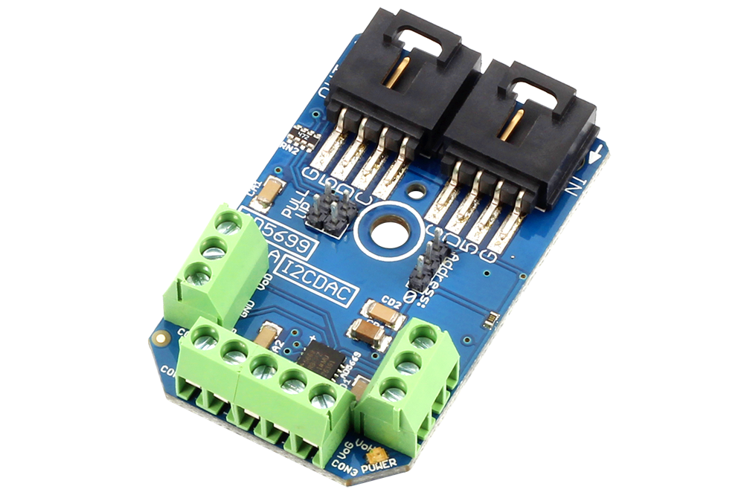

*Figure 5.3.6-1 [28]: AD5669 Digital to Analog Converter Card. Compatible with I2C connection and Raspberry Pi. Has 8 DAC channels and 3 ground channels.*

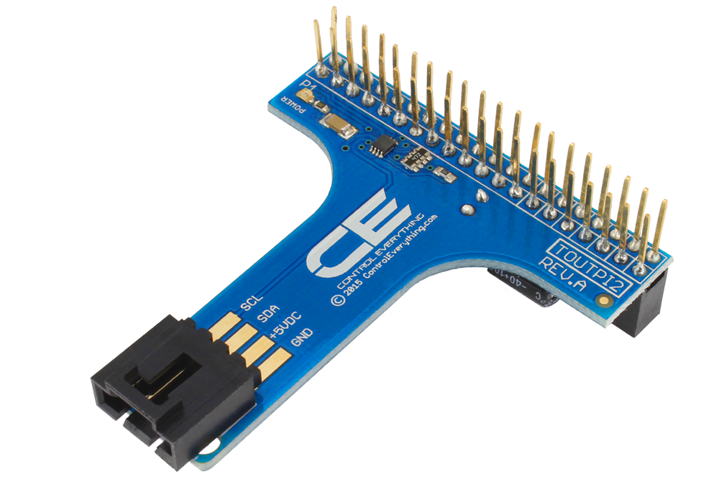

*Figure 5.3.5-2 [29]: Adapter compatible with the AD5669 DAC. Pinout shown on right hooks up seamlessly with Raspberry Pi 3B.*

The DAC card came with an elementary source code found on its Github repository. The code simply writes a uniform voltage to all eight channels simultaneously, with no gradual application or frequency. The voltage magnitude is obscured, as there is a complex. Additionally, the addresses of the DAC’s I2C buses are included, but not documented. The DAC source code can be found in Appendix 1.

**5.3.6-2 Test Code Development**

Two steps needed to be tackled next: one, the hexadecimal command arguments had to be researched and understood, and two, the mathematical conversion needed to be refined and integrated into the Python code to allow for easy leg length to voltage conversions. Using pages 22-24 of the AD5669 DAC Datasheet, the input shift register was reviewed, so as to comprehend how the data was being transmitted from the Pi to the DAC at the byte level. Using the table below, as well as a binary to hexadecimal conversion tool, the write to needed command definitions and addresses were found. Using the hexadecimal equivalents of the writing command byte and the legs’ respective codes, addresses were developed for each of the six legs. These addresses were programmed into the pre-existing “write_i2c_block_data” method included in the SMBus library from the source code. At this point, the team was able to write arbitrary values to each leg, so that some movement could be detected.

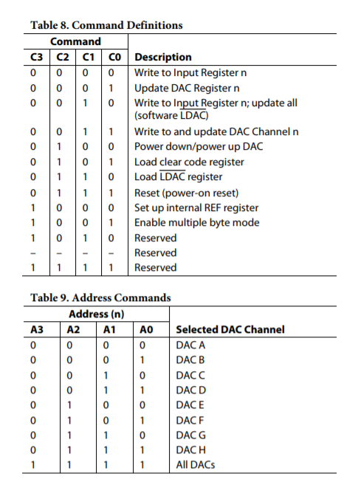

*Figure 5.3.6-2 [30]: AD5669 DAC command definitions and address commands for each specific terminal, in binary.*

Next, the mathematical conversion from hexadecimal to decimal was analyzed. The data array in the code had two arguments: one for any given number, and the other for zero. This would enable the leg to extend to a certain value and then retract back to zero, which was safer and more effective for testing purposes. The conversion was found to be roughly 1/51.2, from hex to decimal. Discovering this enabled the DAC to emit more accurate voltage signals.

Lastly, a method needed to be devised in order to increase extend the leg gradually from zero to a given value. The way the source code was written, the voltage output would change from zero to a value instantaneously, meaning the leg controller would force the leg outwards at an extraordinary speed. For safety, and also simulator operation, a smooth progression was desired. In order to accomplish this, a for loop running many iterations with a very small delay time was implemented. The many iterations allowed for small changes to the leg lengths to be made very quickly, so much so as to mimic smooth motion. The time delay used was about 0.02 seconds, with over 200 iterations. This way, in testing, the platform would reach each desired destination smoothly, and within the same time period. Given the nature of the digital to analog conversion, it was determined that a truly smooth curve was impossible to implement. However, the method employed yields a fairly smooth and reliable course of motion in the platform.

As a finishing touch, print statements were put in the test code so that each change in voltage could be displayed and recorded. The test code went through a few iterations. The first (in Appendix 2) shows the simplified mathematical conversion in conjunction with the loop method of smooth control. The second test code can be seen in Appendix 3 and is able to send each leg to a different length, and bring them back down again smoothly. This proves the capability of the Pi-Python-DAC system to send the platform to any position or attitude and bring it back down again, with an accuracy of about 0.02 in.

**5.3.7 Final Flight Profile**

The test code proved the possibility of controlling each leg to a fair degree of accuracy, simultaneously. It also developed the ability to run a smooth and continuous test. The next step was to develop a prescribed flight profile that would demonstrate the platform’s six degrees of freedom. The same techniques were used as in the test code. The platform would move upwards slowly through a for loop with multiple iterations and small time delays, and then it would follow a similar reverse loop to return to zero. However, in the flight profile, the platform would run through six individual loops. The first three represent motions in the x, y, and z directions of the universal coordinate system. The last three show roll, pitch, and yaw motion. The leg lengths were calculated in the Simulink model described above, and a table of the leg lengths for each attitude can be seen in that section (Table 5.3.5-1). The resulting flight profile consists of two set of code: one for translational motion (18 total inputs), and a second that automatically launches from the end of the first code (another 18 inputs). The full flight profile can be seen in Appendix 4. One of the initial reach goals for this project was to connect the MATLAB model to Microsoft’s XPlane 10 flight simulator software so that a more realistic flight profile could be developed. However, the software integration proved itself outside the bounds of this project, as the team was focused on getting the platform operationally responding to digital commands.

An addendum to the final flight profile is a code that can accept the leg lengths computed in Simulink directly. The code converts these lengths from inches to voltages within the Python code directly, due to a factor the team contrived through a series of measurements and tests. This last bit of code is more of a precursor of what’s to come. The ideal goal is for the Simulink leg lengths to be automatically fed into the Python code in real time, and for the Python code to respond. A PID controller was also developed in Simulink for this reason. However, given the team’s lack of experience with intercomputer networking, there was trouble feeding the MATLAB commands into the Python code without third party manual intervention. This will be one part the following team begins on and attempts to improve. The last code, with its own leg to voltage conversions, can be found in Appendix 5.

**6. Costs**

The budget for this project was set at $5000 thanks in part to Boeing’s sponsorship. **Table 6-1** shows the parts that were needed to complete the project, whereas **Table 6-2** shows the assets that were acquired through the engineering department at no expense to the budget.

|  |  |  |  |
| --- | --- | --- | --- |
| **Part** | **Unit Price** | **Quantity** | **Price** |
| Analog Digital Converter | $115.00 | 1 | $115.00 |
| DC Power Supplies | $60.00 | 3 | $180.00 |
| Miscellaneous Tools | $100.00 | 1 | $100.00 |
| Piping and Electronics | $65.00 | 1 | $65.00 |
| Raspberry Pi | $35.00 | 1 | $35.00 |
| Total |  |  | $495.00 |

*Table 6-1: Budget for the Project*

|  |  |  |  |
| --- | --- | --- | --- |
| **Part** | **Unit Price** | **Quantity** | **Price** |
| Air Compressor | $200.00* | 1 | $200.00 |
| Saitek Flight Controls | $450.00* | 1 | $450.00 |
| Stewart Platform | $10000.00* | 1 | $10000.00 |
| X Plane 10 Software | $50.00 | 1 | $50.00 |
| Total |  |  | $10700.00 |

*Table 6-2: Current Assets (* indicates estimated cost)*

**7. Concluding Remarks**

This Capstone project can be characterized as a success. All of the major goals were able to be accomplished and the handoff to the next group is complete. The motion base was taken from a crate to being unpackaged and setup correctly to now finally being able to accept digital commands from a raspberry pi. The work completed this year has laid the foundation down for this project to be able to grow properly in the future. Without the actual base itself being properly configured and set up, there would be no chance for success. Next year’s group will integrate the flight control with the motion base. This will allow the desired x, y, z, roll, pitch, yaw values to come from the joystick instead of being manually entered into the MATLAB code. Ultimately the goal for this project is to be placed in the CAVE. This will allow a complete VR experience for the user. The platform will be able to fly according to the flight controls by user and the user will be seeing a flight simulation on the CAVE screens. This project is just beginning and has a long way to go.

**8. Appendix**

**Appendix 1: Source code for AD5669 from Github Repository**

1 # Distributed with a free-will license.  
 2 # Use it any way you want, profit or free, provided it fits in the licenses of its associated works.  
 3 # AD5669  
 4 # This code is designed to work with the AD5669_I2CDAC I2C Mini Module available from ControlEverything.com.  
 5 # https://www.controleverything.com/content/Digital-Analog?sku=AD5669_I2CDAC#tabs-0-product_tabset-2  
 6   
 7 import smbus  
 8 import time  
 9   
10 # Get I2C bus  
11 bus = smbus.SMBus(1)  
12   
13 # AD5669 address, 0x56(86)  
14 # Select DAC and input register, 0x2F(47)  
15 # 0x8000(32768) Selected all DAC channels  
16 data = [0x80, 0x00]  
17 bus.write_i2c_block_data(0x56, 0x2F, data)  
18   
19 time.sleep(0.5)  
20   
21 # Convert the data  
22 voltage = ((data[0] * 256 + data[1]) / 65536.0) * 5.0  
23   
24 # Output data to screen  
25 print "Voltage : %.2f V" %voltage

**Appendix 2: Test code #1- shows the conversion simplification, as well as application of the for loop for smoother motion**

1 import smbus  
 2 import time  
 3 import numpy as np  
 4   
 5 # Get I2C bus  
 6 bus = smbus.SMBus(1)  
 7   
 8 time.sleep(0.5)  
 9   
10 # Convert the data  
11 t = np.arange(0,240,1)  
12 for i in range(0,240): # For loop for smooth transition  
13 data = [0x01*t[i], 0x00] # data array containing value and 0  
14 voltage = data[0]/51.2 # simplified data conversion  
15 i+=1  
16 time.sleep(0.02)  
17 print "Voltage : %.2f V" %voltage # voltage print statement  
18 bus.write_i2c_block_data(0x56, 0x2F, data)  
19 t = np.arange(0,240,1)  
20 for i in range(0,240): # loop to go back down to 0 for safety  
21 data = [0x01*t[239-i], 0x00]  
22 voltage = data[0]/51.2  
23 i+=1  
24 time.sleep(0.02)  
25 print "Voltage : %.2f V" %voltage  
26 bus.write_i2c_block_data(0x56, 0x2F, data)

**Appendix 3: Test code #2, shows the ability to control each leg individually**

1   
 2 import smbus  
 3 import time  
 4 import numpy as np  
 5   
 6 # Get I2C bus  
 7 bus = smbus.SMBus(1)  
 8   
 9 # Data input from user into command line  
 10 decA=float(raw_input("Leg Voltage 1: "))  
 11 decB=float(raw_input("Leg Voltage 2: "))  
 12 decC=float(raw_input("Leg Voltage 3: "))  
 13 decD=float(raw_input("Leg Voltage 4: "))  
 14 decE=float(raw_input("Leg Voltage 5: "))  
 15 decF=float(raw_input("Leg Voltage 6: "))  
 16   
 17 t = np.arange(0,201,1)  
 18 for i in range(0,201):   
 19 time.sleep(0.02)  
 20   
 21 # Commands for Leg 1  
 22 dataA= [int(round(decA*t[i]/4)), 0x00]  
 23 bus.write_i2c_block_data(0x56, 0x20, dataA)  
 24 voltA=float(dataA[0])/51.0  
 25   
 26 # Commands for Leg 2  
 27 dataB = [int(round(decB*t[i]/4)), 0x00]  
 28 bus.write_i2c_block_data(0x56, 0x21, dataB)  
 29 voltB=float(dataB[0])/51.0  
 30   
 31 # Commands for Leg 3  
 32 dataC= [int(round(decC*t[i]/4)), 0x00]  
 33 bus.write_i2c_block_data(0x56, 0x22, dataC)  
 34 voltC=float(dataC[0])/51.0  
 35   
 36 # Commands for Leg 4  
 37 dataD = [int(round(decD*t[i]/4)), 0x00]  
 38 bus.write_i2c_block_data(0x56, 0x23, dataD)  
 39 voltD=float(dataD[0])/51.0  
 40   
 41 # Commands for Leg 5  
 42 dataE = [int(round(decE*t[i]/4)), 0x00]  
 43 bus.write_i2c_block_data(0x56, 0x24, dataE)  
 44 voltE=float(dataE[0])/51.0  
 45   
 46 # Commands for Leg 6  
 47 dataF= [int(round(decF*t[i]/4)), 0x00]  
 48 bus.write_i2c_block_data(0x56, 0x25, dataF)  
 49 voltF=float(dataF[0])/51.0  
 50   
 51 i+=1  
 52   
 53 # Print statements  
 54 print "Leg 1 : %.2f V" %voltA  
 55 print "Leg 2 : %.2f V" %voltB  
 56 print "Leg 3 : %.2f V" %voltC  
 57 print "Leg 4 : %.2f V" %voltD  
 58 print "Leg 5 : %.2f V" %voltE  
 59 print "Leg 6 : %.2f V" %voltF  
 60   
 61 time.sleep(0.5)  
 62   
 63 for i in range(0,201):   
 64 time.sleep(0.02)  
 65   
 66 # Commands for Leg 1  
 67 dataA= [int(round(decA*t[200-i]/4)), 0x00]  
 68 bus.write_i2c_block_data(0x56, 0x20, dataA)  
 69 voltA=float(dataA[0])/51.0  
 70   
 71 # Commands for Leg 2  
 72 dataB = [int(round(decB*t[200-i]/4)), 0x00]  
 73 bus.write_i2c_block_data(0x56, 0x21, dataB)  
 74 voltB=float(dataB[0])/51.0  
 75   
 76 # Commands for Leg 3  
 77 dataC= [int(round(decC*t[200-i]/4)), 0x00]  
 78 bus.write_i2c_block_data(0x56, 0x22, dataC)  
 79 voltC=float(dataC[0])/51.0  
 80   
 81 # Commands for Leg 4  
 82 dataD = [int(round(decD*t[200-i]/4)), 0x00]  
 83 bus.write_i2c_block_data(0x56, 0x23, dataD)  
 84 voltD=float(dataD[0])/51.0  
 85   
 86 # Commands for Leg 5  
 87 dataE = [int(round(decE*t[200-i]/4)), 0x00]  
 88 bus.write_i2c_block_data(0x56, 0x24, dataE)  
 89 voltE=float(dataE[0])/51.0  
 90   
 91 # Commands for Leg 6  
 92 dataF= [int(round(decF*t[200-i]/4)), 0x00]  
 93 bus.write_i2c_block_data(0x56, 0x25, dataF)  
 94 voltF=float(dataF[0])/51.0  
 95   
 96 i+=1  
 97   
 98 # Print statements  
 99 print "Leg 1 : %.2f V" %voltA  
100 print "Leg 2 : %.2f V" %voltB  
101 print "Leg 3 : %.2f V" %voltC  
102 print "Leg 4 : %.2f V" %voltD  
103 print "Leg 5 : %.2f V" %voltE  
104 print "Leg 6 : %.2f V" %voltF  
105

**Appendix 4: Flight Profile Part 1, showing the “up and down” motions for the three translational coordinate directions: x, y, and z. The angular motions were performed in a nearly identical code that was launched automatically from the first.**

1 import smbus  
 2 import time  
 3 import numpy as np  
 4   
 5 # Get I2C bus  
 6 bus = smbus.SMBus(1)  
 7   
 8 # Data input from user into command line  
 9 print "Round One - X"  
 10 decA=5  
 11 decB=5  
 12 decC=5  
 13 decD=5  
 14 decE=2  
 15 decF=2  
 16 print "Round Two - Y"  
 17 decG=5  
 18 decH=5  
 19 decI=2  
 20 decJ=2  
 21 decK=5  
 22 decL=5  
 23 print "Round Three - Z"  
 24 decM=5  
 25 decN=5  
 26 decO=5  
 27 decP=5  
 28 decQ=5  
 29 decR=5  
 30   
 31 t = np.arange(0,201,1)  
 32 for i in range(0,201):   
 33 time.sleep(0.02)  
 34   
 35 # X-Motion   
 36   
 37 # Commands for Leg 1  
 38 dataA= [int(round(decA*t[i]/4)), 0x00]  
 39 bus.write_i2c_block_data(0x56, 0x20, dataA)  
 40 voltA=float(dataA[0])/51.0  
 41   
 42 # Commands for Leg 2  
 43 dataB = [int(round(decB*t[i]/4)), 0x00]  
 44 bus.write_i2c_block_data(0x56, 0x21, dataB)  
 45 voltB=float(dataB[0])/51.0  
 46   
 47 # Commands for Leg 3  
 48 dataC= [int(round(decC*t[i]/4)), 0x00]  
 49 bus.write_i2c_block_data(0x56, 0x22, dataC)  
 50 voltC=float(dataC[0])/51.0  
 51   
 52 # Commands for Leg 4  
 53 dataD = [int(round(decD*t[i]/4)), 0x00]  
 54 bus.write_i2c_block_data(0x56, 0x23, dataD)  
 55 voltD=float(dataD[0])/51.0  
 56   
 57 # Commands for Leg 5  
 58 dataE = [int(round(decE*t[i]/4)), 0x00]  
 59 bus.write_i2c_block_data(0x56, 0x24, dataE)  
 60 voltE=float(dataE[0])/51.0  
 61   
 62 # Commands for Leg 6  
 63 dataF= [int(round(decF*t[i]/4)), 0x00]  
 64 bus.write_i2c_block_data(0x56, 0x25, dataF)  
 65 voltF=float(dataF[0])/51.0  
 66   
 67 i+=1  
 68   
 69 # Print statements  
 70 print "Leg 1 : %.2f V" %voltA  
 71 print "Leg 2 : %.2f V" %voltB  
 72 print "Leg 3 : %.2f V" %voltC  
 73 print "Leg 4 : %.2f V" %voltD  
 74 print "Leg 5 : %.2f V" %voltE  
 75 print "Leg 6 : %.2f V" %voltF  
 76   
 77 time.sleep(0.5)  
 78   
 79 for i in range(0,201):   
 80 time.sleep(0.02)  
 81   
 82 # Commands for Leg 1  
 83 dataA= [int(round(decA*t[200-i]/4)), 0x00]  
 84 bus.write_i2c_block_data(0x56, 0x20, dataA)  
 85 voltA=float(dataA[0])/51.0  
 86   
 87 # Commands for Leg 2  
 88 dataB = [int(round(decB*t[200-i]/4)), 0x00]  
 89 bus.write_i2c_block_data(0x56, 0x21, dataB)  
 90 voltB=float(dataB[0])/51.0  
 91   
 92 # Commands for Leg 3  
 93 dataC= [int(round(decC*t[200-i]/4)), 0x00]  
 94 bus.write_i2c_block_data(0x56, 0x22, dataC)  
 95 voltC=float(dataC[0])/51.0  
 96   
 97 # Commands for Leg 4  
 98 dataD = [int(round(decD*t[200-i]/4)), 0x00]  
 99 bus.write_i2c_block_data(0x56, 0x23, dataD)  
100 voltD=float(dataD[0])/51.0  
101   
102 # Commands for Leg 5  
103 dataE = [int(round(decE*t[200-i]/4)), 0x00]  
104 bus.write_i2c_block_data(0x56, 0x24, dataE)  
105 voltE=float(dataE[0])/51.0  
106   
107 # Commands for Leg 6  
108 dataF= [int(round(decF*t[200-i]/4)), 0x00]  
109 bus.write_i2c_block_data(0x56, 0x25, dataF)  
110 voltF=float(dataF[0])/51.0  
111   
112 i+=1  
113   
114 # Print statements  
115 print "Leg 1 : %.2f V" %voltA  
116 print "Leg 2 : %.2f V" %voltB  
117 print "Leg 3 : %.2f V" %voltC  
118 print "Leg 4 : %.2f V" %voltD  
119 print "Leg 5 : %.2f V" %voltE  
120 print "Leg 6 : %.2f V" %voltF  
121   
122 # Y-Motion  
123   
124 for i in range(0,201):   
125 time.sleep(0.02)  
126   
127 # Commands for Leg 1  
128 dataG= [int(round(decG*t[i]/4)), 0x00]  
129 bus.write_i2c_block_data(0x56, 0x20, dataG)  
130 voltA=float(dataG[0])/51.0  
131   
132 # Commands for Leg 2  
133 dataH = [int(round(decH*t[i]/4)), 0x00]  
134 bus.write_i2c_block_data(0x56, 0x21, dataH)  
135 voltB=float(dataH[0])/51.0  
136   
137 # Commands for Leg 3  
138 dataI= [int(round(decI*t[i]/4)), 0x00]  
139 bus.write_i2c_block_data(0x56, 0x22, dataI)  
140 voltC=float(dataI[0])/51.0  
141   
142 # Commands for Leg 4  
143 dataJ = [int(round(decJ*t[i]/4)), 0x00]  
144 bus.write_i2c_block_data(0x56, 0x23, dataJ)  
145 voltD=float(dataJ[0])/51.0  
146   
147 # Commands for Leg 5  
148 dataK = [int(round(decK*t[i]/4)), 0x00]  
149 bus.write_i2c_block_data(0x56, 0x24, dataK)  
150 voltE=float(dataK[0])/51.0  
151   
152 # Commands for Leg 6  
153 dataL= [int(round(decL*t[i]/4)), 0x00]  
154 bus.write_i2c_block_data(0x56, 0x25, dataL)  
155 voltF=float(dataL[0])/51.0  
156   
157 i+=1  
158   
159 # Print statements  
160 print "Leg 1 : %.2f V" %voltA  
161 print "Leg 2 : %.2f V" %voltB  
162 print "Leg 3 : %.2f V" %voltC  
163 print "Leg 4 : %.2f V" %voltD  
164 print "Leg 5 : %.2f V" %voltE  
165 print "Leg 6 : %.2f V" %voltF  
166   
167 time.sleep(0.5)  
168   
169 for i in range(0,201):   
170 time.sleep(0.02)  
171   
172 # Commands for Leg 1  
173 dataG= [int(round(decG*t[200-i]/4)), 0x00]  
174 bus.write_i2c_block_data(0x56, 0x20, dataG)  
175 voltA=float(dataG[0])/51.0  
176   
177 # Commands for Leg 2  
178 dataH = [int(round(decH*t[200-i]/4)), 0x00]  
179 bus.write_i2c_block_data(0x56, 0x21, dataH)  
180 voltB=float(dataH[0])/51.0  
181   
182 # Commands for Leg 3  
183 dataI= [int(round(decI*t[200-i]/4)), 0x00]  
184 bus.write_i2c_block_data(0x56, 0x22, dataI)  
185 voltC=float(dataI[0])/51.0  
186   
187 # Commands for Leg 4  
188 dataJ = [int(round(decJ*t[200-i]/4)), 0x00]  
189 bus.write_i2c_block_data(0x56, 0x23, dataJ)  
190 voltD=float(dataJ[0])/51.0  
191   
192 # Commands for Leg 5  
193 dataK = [int(round(decK*t[200-i]/4)), 0x00]  
194 bus.write_i2c_block_data(0x56, 0x24, dataK)  
195 voltE=float(dataK[0])/51.0  
196   
197 # Commands for Leg 6  
198 dataL= [int(round(decL*t[200-i]/4)), 0x00]  
199 bus.write_i2c_block_data(0x56, 0x25, dataL)  
200 voltF=float(dataL[0])/51.0  
201   
202 i+=1  
203   
204 # Print statements  
205 print "Leg 1 : %.2f V" %voltA  
206 print "Leg 2 : %.2f V" %voltB  
207 print "Leg 3 : %.2f V" %voltC  
208 print "Leg 4 : %.2f V" %voltD  
209 print "Leg 5 : %.2f V" %voltE  
210 print "Leg 6 : %.2f V" %voltF  
211   
212 # Z-Motion  
213   
214 for i in range(0,201):   
215 time.sleep(0.02)  
216   
217 # Commands for Leg 1  
218 dataM= [int(round(decM*t[i]/4)), 0x00]  
219 bus.write_i2c_block_data(0x56, 0x20, dataM)  
220 voltA=float(dataM[0])/51.0  
221   
222 # Commands for Leg 2  
223 dataN = [int(round(decN*t[i]/4)), 0x00]  
224 bus.write_i2c_block_data(0x56, 0x21, dataN)  
225 voltB=float(dataN[0])/51.0  
226   
227 # Commands for Leg 3  
228 dataO= [int(round(decO*t[i]/4)), 0x00]  
229 bus.write_i2c_block_data(0x56, 0x22, dataO)  
230 voltC=float(dataO[0])/51.0  
231   
232 # Commands for Leg 4  
233 dataP = [int(round(decP*t[i]/4)), 0x00]  
234 bus.write_i2c_block_data(0x56, 0x23, dataP)  
235 voltD=float(dataP[0])/51.0  
236   
237 # Commands for Leg 5  
238 dataQ = [int(round(decQ*t[i]/4)), 0x00]  
239 bus.write_i2c_block_data(0x56, 0x24, dataQ)  
240 voltE=float(dataQ[0])/51.0  
241   
242 # Commands for Leg 6  
243 dataR= [int(round(decR*t[i]/4)), 0x00]  
244 bus.write_i2c_block_data(0x56, 0x25, dataR)  
245 voltF=float(dataR[0])/51.0  
246   
247 i+=1  
248   
249 # Print statements  
250 print "Leg 1 : %.2f V" %voltA  
251 print "Leg 2 : %.2f V" %voltB  
252 print "Leg 3 : %.2f V" %voltC  
253 print "Leg 4 : %.2f V" %voltD  
254 print "Leg 5 : %.2f V" %voltE  
255 print "Leg 6 : %.2f V" %voltF  
256   
257 time.sleep(0.5)  
258   
259 for i in range(0,201):   
260 time.sleep(0.02)  
261   
262 # Commands for Leg 1  
263 dataM= [int(round(decM*t[200-i]/4)), 0x00]  
264 bus.write_i2c_block_data(0x56, 0x20, dataM)  
265 voltA=float(dataM[0])/51.0  
266   
267 # Commands for Leg 2  
268 dataN = [int(round(decN*t[200-i]/4)), 0x00]  
269 bus.write_i2c_block_data(0x56, 0x21, dataN)  
270 voltB=float(dataN[0])/51.0  
271   
272 # Commands for Leg 3  
273 dataO= [int(round(decO*t[200-i]/4)), 0x00]  
274 bus.write_i2c_block_data(0x56, 0x22, dataO)  
275 voltC=float(dataO[0])/51.0  
276   
277 # Commands for Leg 4  
278 dataP = [int(round(decP*t[200-i]/4)), 0x00]  
279 bus.write_i2c_block_data(0x56, 0x23, dataP)  
280 voltD=float(dataP[0])/51.0  
281   
282 # Commands for Leg 5  
283 dataQ = [int(round(decQ*t[200-i]/4)), 0x00]  
284 bus.write_i2c_block_data(0x56, 0x24, dataQ)  
285 voltE=float(dataQ[0])/51.0  
286   
287 # Commands for Leg 6  
288 dataR= [int(round(decR*t[200-i]/4)), 0x00]  
289 bus.write_i2c_block_data(0x56, 0x25, dataR)  
290 voltF=float(dataR[0])/51.0  
291   
292 i+=1  
293   
294 # Print statements  
295 print "Leg 1 : %.2f V" %voltA  
296 print "Leg 2 : %.2f V" %voltB  
297 print "Leg 3 : %.2f V" %voltC  
298 print "Leg 4 : %.2f V" %voltD  
299 print "Leg 5 : %.2f V" %voltE  
300 print "Leg 6 : %.2f V" %voltF  
301   
302 execfile("FinalDemo2.py") # automatically executes the second half of the flight profile, the roll, pitch, and yaw demonstration  
303

**Appendix 5: Simulink Test Code, with Python converting from leg lengths to voltages on its own.**

1 import smbus  
 2 import time  
 3 import numpy as np  
 4   
 5 # Get I2C bus  
 6 bus = smbus.SMBus(1)  
 7   
 8 # Data input from user into command line  
 9 decA=float(raw_input("Leg Length 1: "))*.62 # conversion  
 10 decB=float(raw_input("Leg Length 2: "))*.62  
 11 decC=float(raw_input("Leg Length 3: "))*.62  
 12 decD=float(raw_input("Leg Length 4: "))*.62  
 13 decE=float(raw_input("Leg Length 5: "))*.62  
 14 decF=float(raw_input("Leg Length 6: "))*.62  
 15   
 16 t = np.arange(0,201,1)  
 17 for i in range(0,201):   
 18 time.sleep(0.02)  
 19   
 20 # Commands for Leg 1  
 21 dataA= [int(round(decA*t[i]/4)), 0x00]  
 22 bus.write_i2c_block_data(0x56, 0x20, dataA)  
 23 voltA=float(dataA[0])/51.0  
 24   
 25 # Commands for Leg 2  
 26 dataB = [int(round(decB*t[i]/4)), 0x00]  
 27 bus.write_i2c_block_data(0x56, 0x21, dataB)  
 28 voltB=float(dataB[0])/51.0  
 29   
 30 # Commands for Leg 3  
 31 dataC= [int(round(decC*t[i]/4)), 0x00]  
 32 bus.write_i2c_block_data(0x56, 0x22, dataC)  
 33 voltC=float(dataC[0])/51.0  
 34   
 35 # Commands for Leg 4  
 36 dataD = [int(round(decD*t[i]/4)), 0x00]  
 37 bus.write_i2c_block_data(0x56, 0x23, dataD)  
 38 voltD=float(dataD[0])/51.0  
 39   
 40 # Commands for Leg 5  
 41 dataE = [int(round(decE*t[i]/4)), 0x00]  
 42 bus.write_i2c_block_data(0x56, 0x24, dataE)  
 43 voltE=float(dataE[0])/51.0  
 44   
 45 # Commands for Leg 6  
 46 dataF= [int(round(decF*t[i]/4)), 0x00]  
 47 bus.write_i2c_block_data(0x56, 0x25, dataF)  
 48 voltF=float(dataF[0])/51.0  
 49   
 50 i+=1  
 51   
 52 # Print statements  
 53 print "Leg 1 : %.2f V" %voltA  
 54 print "Leg 2 : %.2f V" %voltB  
 55 print "Leg 3 : %.2f V" %voltC  
 56 print "Leg 4 : %.2f V" %voltD  
 57 print "Leg 5 : %.2f V" %voltE  
 58 print "Leg 6 : %.2f V" %voltF  
 59   
 60 time.sleep(0.5)  
 61   
 62 for i in range(0,201):   
 63 time.sleep(0.02)  
 64   
 65 # Commands for Leg 1  
 66 dataA= [int(round(decA*t[200-i]/4)), 0x00]  
 67 bus.write_i2c_block_data(0x56, 0x20, dataA)  
 68 voltA=float(dataA[0])/51.0  
 69   
 70 # Commands for Leg 2  
 71 dataB = [int(round(decB*t[200-i]/4)), 0x00]  
 72 bus.write_i2c_block_data(0x56, 0x21, dataB)  
 73 voltB=float(dataB[0])/51.0  
 74   
 75 # Commands for Leg 3  
 76 dataC= [int(round(decC*t[200-i]/4)), 0x00]  
 77 bus.write_i2c_block_data(0x56, 0x22, dataC)  
 78 voltC=float(dataC[0])/51.0  
 79   
 80 # Commands for Leg 4  
 81 dataD = [int(round(decD*t[200-i]/4)), 0x00]  
 82 bus.write_i2c_block_data(0x56, 0x23, dataD)  
 83 voltD=float(dataD[0])/51.0  
 84   
 85 # Commands for Leg 5  
 86 dataE = [int(round(decE*t[200-i]/4)), 0x00]  
 87 bus.write_i2c_block_data(0x56, 0x24, dataE)  
 88 voltE=float(dataE[0])/51.0  
 89   
 90 # Commands for Leg 6  
 91 dataF= [int(round(decF*t[200-i]/4)), 0x00]  
 92 bus.write_i2c_block_data(0x56, 0x25, dataF)  
 93 voltF=float(dataF[0])/51.0  
 94   
 95 i+=1  
 96   
 97 # Print statements  
 98 print "Leg 1 : %.2f V" %voltA  
 99 print "Leg 2 : %.2f V" %voltB  
100 print "Leg 3 : %.2f V" %voltC  
101 print "Leg 4 : %.2f V" %voltD  
102 print "Leg 5 : %.2f V" %voltE  
103 print "Leg 6 : %.2f V" %voltF  
104

**Appendix 6: AD5669 Source code found on github**

# Distributed with a free-will license.

# Use it any way you want, profit or free, provided it fits in the licenses of its associated works.

# AD5669

# This code is designed to work with the AD5669_I2CDAC I2C Mini Module available from ControlEverything.com.

# <https://www.controleverything.com/content/Digital->Analog?sku=AD5669_I2CDAC#tabs-0-product_tabset-2

import smbus

import time

# Get I2C bus

bus = smbus.SMBus(1)

# AD5669 address, 0x56(86)

# Select DAC and input register, 0x2F(47)

# 0x8000(32768) Selected all DAC channels

data = [0x80, 0x00]

bus.write_i2c_block_data(0x56, 0x2F, data)

time.sleep(0.5)

# Convert the data

voltage = ((data[0] * 256 + data[1]) / 65536.0) * 5.0

# Output data to screen

print "Voltage : %.2f V" %voltage

**Appendix 7: MATLAB Code for leg length calculations**

deg2rad = pi/180;

x_axis = [1 0 0];

y_axis = [0 1 0];

z_axis = [0 0 1];

% Connection points on base and top plate w.r.t. World frame at the center

% of the base plate

pos_base = [];

pos_top = [];

alpha_b = 2.5*deg2rad; % +- offset angle from 120 degree spacing on base

alpha_t = 10*deg2rad; % +- offset angle from 120 degree spacing on top

height = 0.7493; % meter height in home configuration

radius_b = 0.3556; % base radius in meters

radius_t = 0.092; % top radius in meters

for i = 1:3,

% base points

angle_m_b = (2*pi/3)* (i-1) - alpha_b;

angle_p_b = (2*pi/3)* (i-1) + alpha_b;

pos_base(2*i-1,:) = radius_b* [cos(angle_m_b), sin(angle_m_b), 0.0];

pos_base(2*i,:) = radius_b* [cos(angle_p_b), sin(angle_p_b), 0.0];

% top points

% Top points are 60 degrees offset

angle_m_t = (2*pi/3)* (i-1) - alpha_t + 2*pi/6;

angle_p_t = (2*pi/3)* (i-1) + alpha_t + 2*pi/6;

pos_top(2*i-1,:) = [radius_t*cos(angle_m_t), radius_t*sin(angle_m_t), height];

pos_top(2*i,:) = [radius_t*cos(angle_p_t), radius_t*sin(angle_p_t), height];

end

% permute pos_top points so that legs are end points of base and top points

pos_top = [pos_top(6,:); pos_top(1:5,:)]; %6th point on top connects to 1st on bottom

% Compute points w.r.t. to the body frame in a 3x6 matrix

body_pts = pos_top' - height*[zeros(2,6);ones(1,6)];

% leg vectors

legs = pos_top - pos_base;

leg_length = [ ];

leg_vectors = [ ];

for i = 1:6,

leg_length(i) = norm(legs(i,:));

leg_vectors(i,:) = legs(i,:) / leg_length(i);

end

**9. REFERENCES (BIBLIOGRAPHY)**

[1]

https://www.doc.ic.ac.uk/~nd/surprise_96/journal/vol1/kwc2/article1.html

[2]

<https://news.virginia.edu/content/flight-simulator-allows-engineering-students-experience-aerodynamics-they-study>

[3]

<https://www.mathworks.com/company/newsletters/articles/creating-a-stewart-platform-model-using-simmechanics.html>

[4]

https://www.nap.edu/read/21674/chapter/4

[5]

<https://media-cdn.tripadvisor.com/media/photo-s/01/c1/c3/b0/virtual-aviation.jpg>

[6]

<http://www.frasca.com/wp-content/uploads/2016/06/CessnaCRJ-200-Cover.jpg>

[7]

<https://flypfc.com/>

[8] https://www.bimba.com/Global/Library/Brochures/SPCS_2_Setup_Manual_10_14_13.pdf

[9] <http://playground.arduino.cc/Main/MPU-6050>

[10] <http://1.bp.blogspot.com/-VD4tnn3Towo/UnkvTpt2WvI/AAAAAAAAA2o/0Aa5WlIVXn8/s1600/mpu-6050.jpg>

[11] file:///C:/Users/bdobk/Downloads/stewart%20platform%20(2).pdf

[12] <https://www.element14.com/community/servlet/JiveServlet/showImage/38-18201-212299/Arduino_Uno.jpg>

[13] <http://images.bit-tech.net/content_images/2013/03/raspberry-pi-case-competition-update/pi1l.jpg>

[14] <http://media.treehugger.com/assets/images/2014/06/raspberry_pi_alternatives.jpg>

[15] <https://www.mathworks.com/help/physmod/sm/mech/ug/modeling-the-stewart-platform.html#f15-36607>

[16] https://www.mathworks.com/help/physmod/sm/mech/ug/generating-and-simulating-with-code.html

[17]

http://blog.opticontrols.com/archives/344

[18]

<https://media.ncd.io/sites/2/20170721134850/AD5629R_5669R.pdf>

[19]

https://github.com/ControlEverythingCommunity/AD5669

STATEMENT OF CONTRIBUTIONS

PRELIMINARY DESIGN WORK

**Research and Development**

Python Research

Stewart Platform Research

**Materials and Testing**

Materials Purchasing

Initial Setup Installation

New Part Installation

DESIGN CONFIGURATIONS

**Final Setup Design**

Installation

Testing

**Python Structure Design**

Research

Coding

Analysis

**MATLAB Leg Lengths**

Research

Coding

Analysis

TECHNICAL ANALYSIS OF FINAL DESIGN

**Safety Concerns**

Installation of Safety Checks

**Movement Stability**

Dynamic Analysis

PID Calibration

Python Coding

**Power Requirements**

Leg Testing

**Structural Requirements**

Platform Stress Analysis

TECHNICAL PRESENTATIONS

**Weekly Reports:**

**Proposal:**

**Progress Report:**

**Preliminary Oral Presentation:**

**Product Demo:**

**Final Report:**

SIGNATURES

B. Dobkowski (60%), M. Ubertaccio (40%)

Entire Team (20% Each)

T. Moldovan (100%)

Entire Team (20% Each)

T. Moldovan (50%), G. Russell (50%)

A. Butler (50%), G. Russell (50%)

T. Moldovan (50%), G. Russell (50%)

B. Dobkowski (70%), M. Ubertaccio (30%)

B. Dobkoski (80%), Rest of Team (20%)

Entire Team (20% Each)

Entire Team (20% Each)

M. Ubertaccio (100%)

M. Ubertaccio (50%), Rest of Team (50%)

T. Moldovan (50%), G. Russell (50%)

A. Butler (60%), G. Russell (40%)

T. Moldovan (60%), G. Russel (40%)

B. Dobkowski (50%), M. Ubertaccio (50%)

T. Moldovan (50%), G. Russell (50%)

M. Ubertaccio (100%)

1. Butler (80%), Rest of Team (20%)

Entire Team (20% Each)

Entire Team (20% Each)

Entire Team (20% Each)

Entire Team (20% Each)

Entire Team (20% Each)